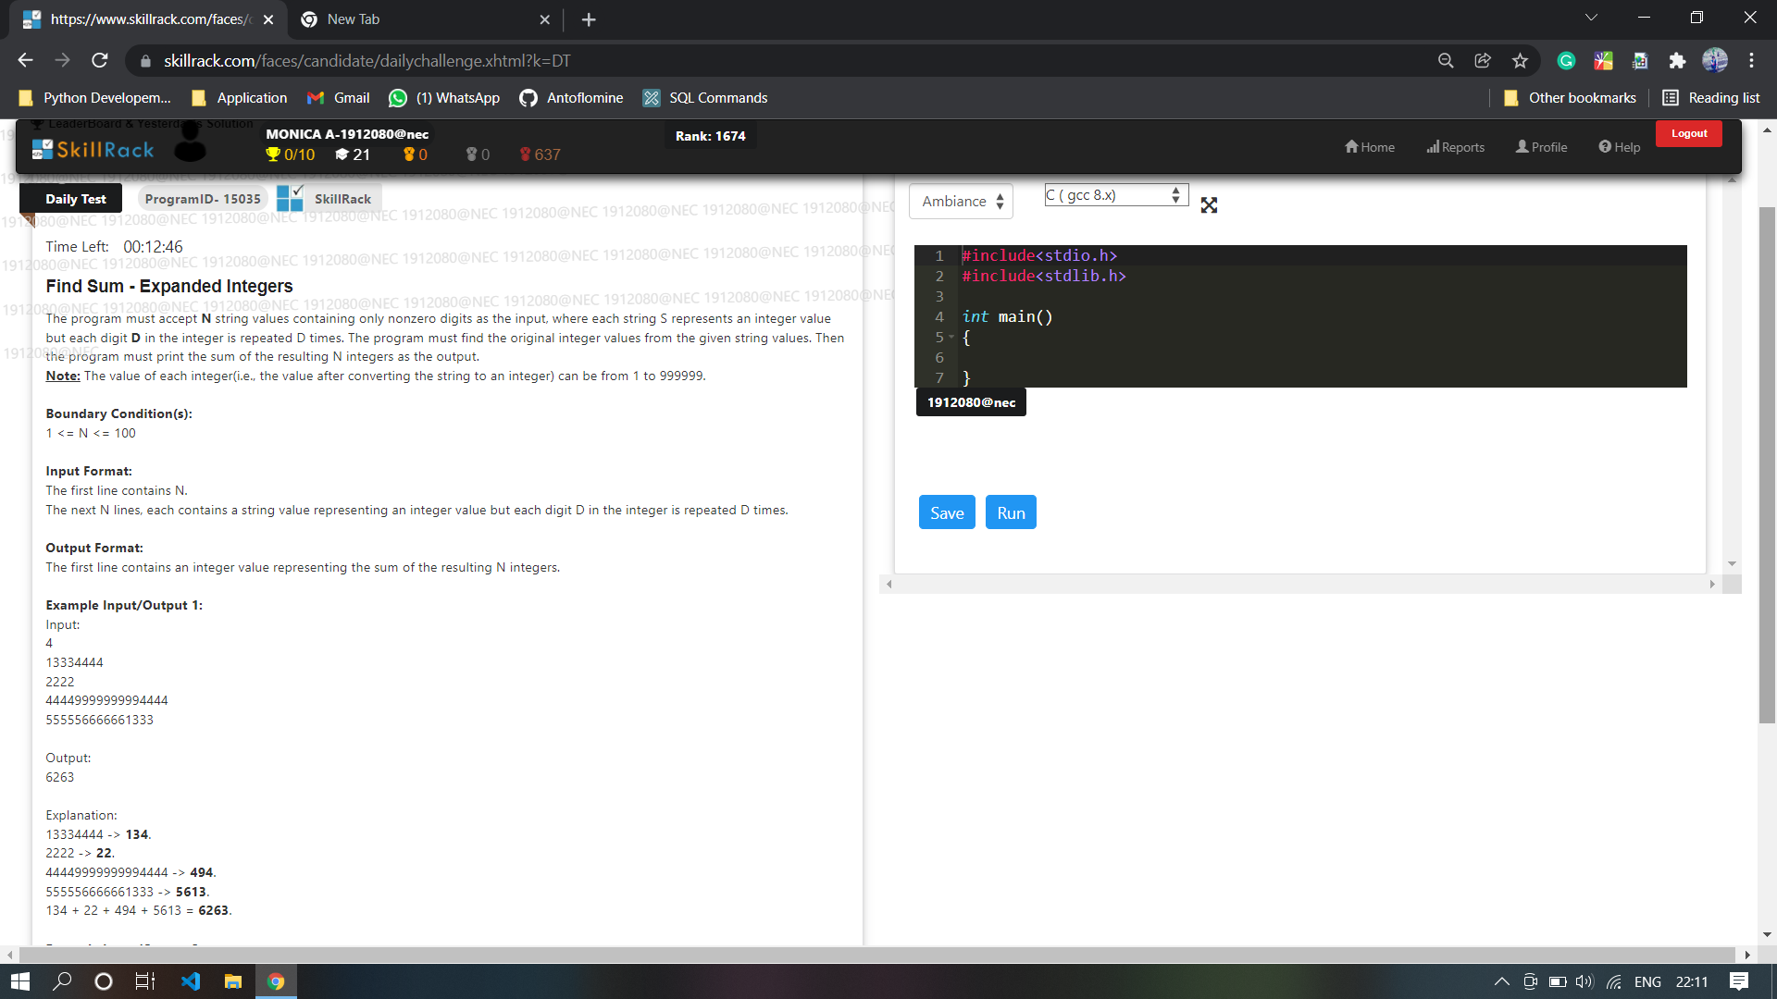

Code:

public class Main

{

public static void main(String[] args) {

int n=4;

int sum=0;

String arr[] ={

"13334444",

"2222",

"44449999999994444",

"555556666661333"

};

for(int j=0;j<n;j++){

String r = arr[j];

String res="";

for(int i=0;i<r.length();){

res+=r.charAt(i);

i+=r.charAt(i)-'0';

}

sum+=Integer.parseInt(res);

//System.out.println(res);

}

System.out.println(sum);

}

}

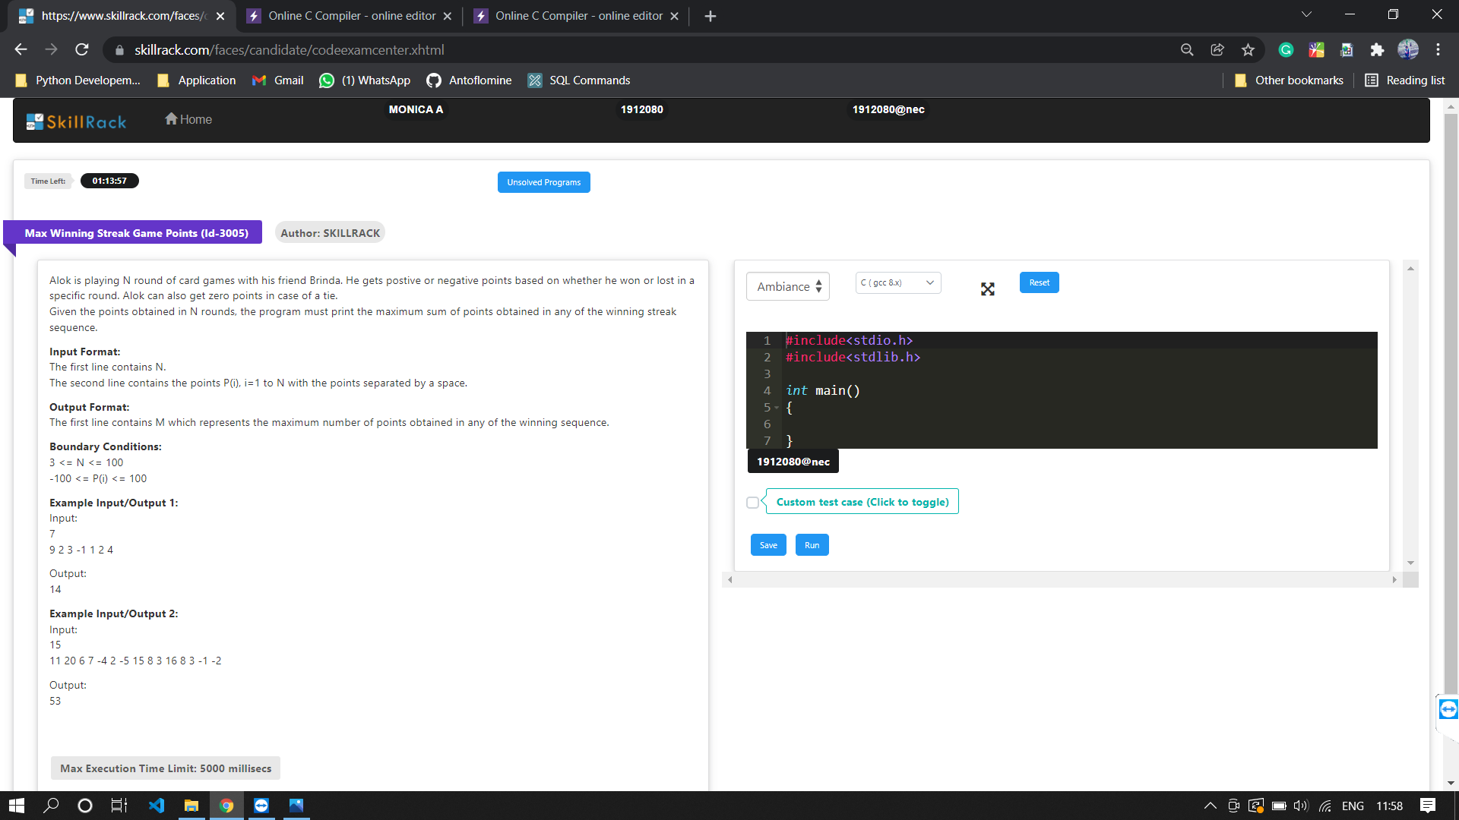

import java.util.\*;

public class Main

{

public static void main(String[] args) {

Scanner sc=new Scanner(System.in);

int n=sc.nextInt();

int[] arr=new int[n];

for(int i=0;i<n;i++){

arr[i]=sc.nextInt();

}

int m=0,s=0;

for(int i=0;i<n;i++){

if(arr[i]>=0){

s=s+arr[i];

}

else{

if(m<s){

m=s;

}

s=0;

}

}

if(m<s){

m=s;

}

System.out.println(m);

}

}

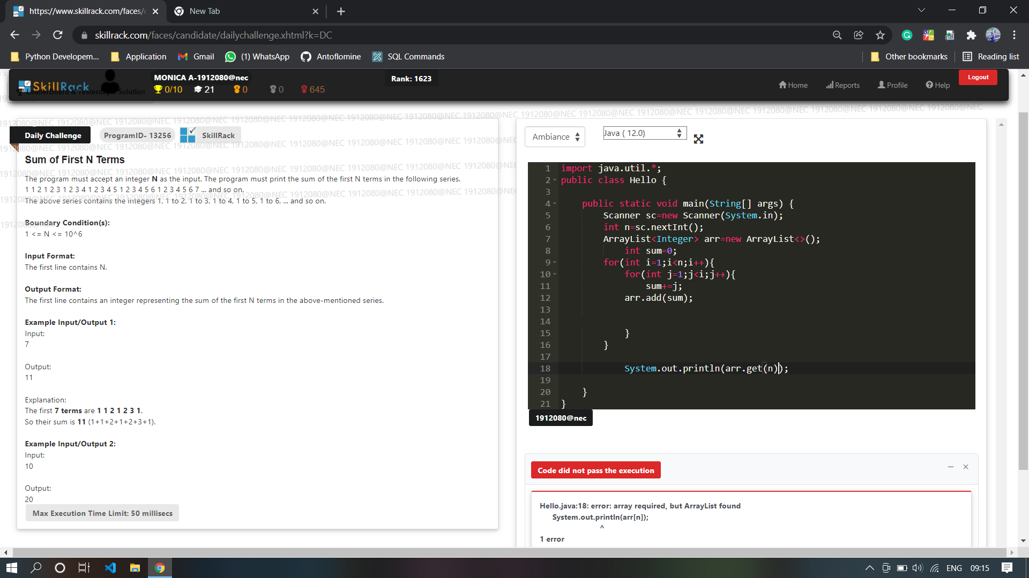

import java.util.\*;

public class Main

{

public static void main (String[]args)

{

Scanner sc = new Scanner (System.in);

int n = sc.nextInt ();

int sum = 0;

int soFarAddedthisNumbers = 0;

for (int i = 1; i <= n; i++){

for (int j = 1; j <= i; j++){

sum += j;

soFarAddedthisNumbers++;

if(soFarAddedthisNumbers==n){

System.out.println(sum);

return;

}

}

}

}

}

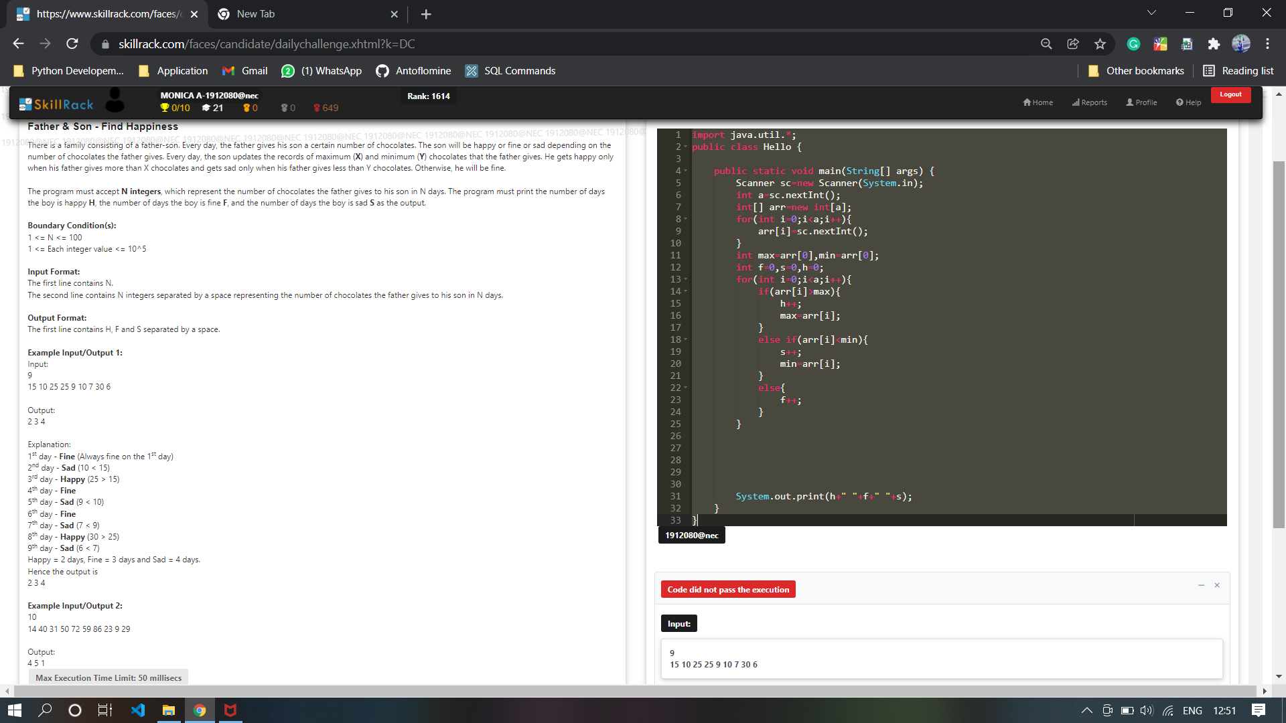

import java.util.\*;

public class Hello {

public static void main(String[] args) {

Scanner sc=new Scanner(System.in);

int a=sc.nextInt();

int[] arr=new int[a];

for(int i=0;i<a;i++){

arr[i]=sc.nextInt();

}

int max=arr[0],min=arr[0];

int f=0,s=0,h=0;

for(int i=0;i<a;i++){

if(arr[i]>max){

h++;

max=arr[i];

}

else if(arr[i]<min){

s++;

min=arr[i];

}

else{

f++;

}

}

System.out.print(h+" "+f+" "+s);

}

}

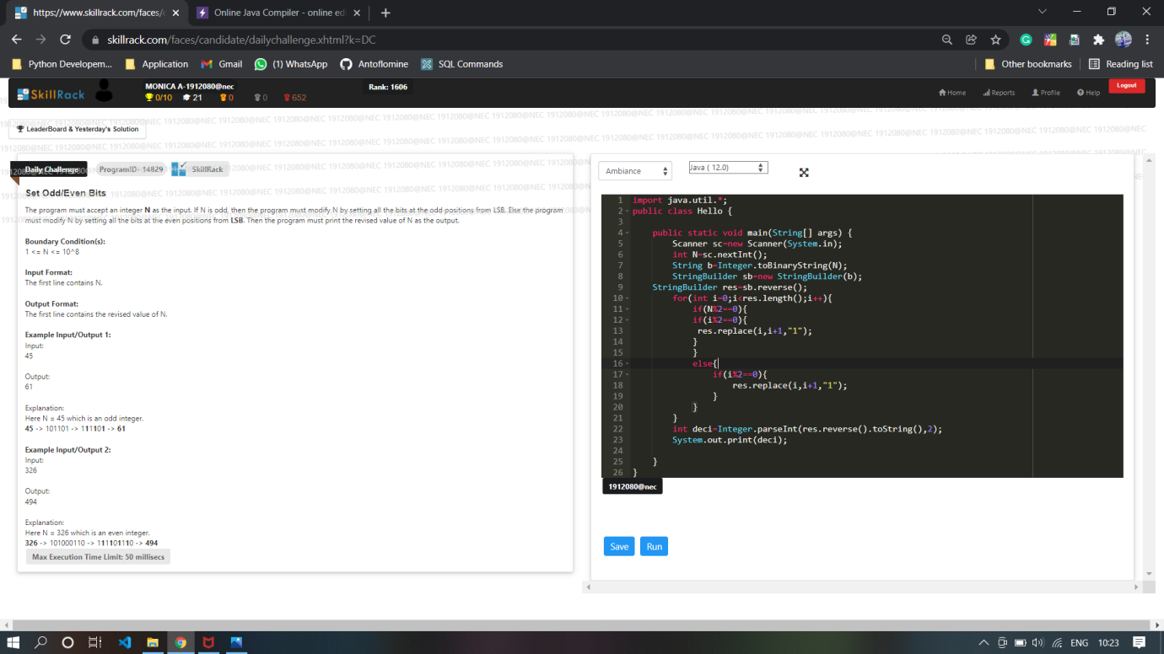

import java.util.\*;

public class Main {

public static void main(String[] args) {

Scanner sc=new Scanner(System.in);

int N=sc.nextInt();

String b=Integer.toBinaryString(N);

StringBuilder sb=new StringBuilder(b);

StringBuilder res=sb.reverse();

//System.out.print(res);

for(int i=0;i<res.length();i++){

if(N%2!=0){

if(i%2==0){

res.replace(i,i+1,"1");

}

}

else{

if(i%2!=0){

res.replace(i,i+1,"1");

}

}

}

int deci=Integer.parseInt(res.reverse().toString(),2);

System.out.print(deci);

}

}

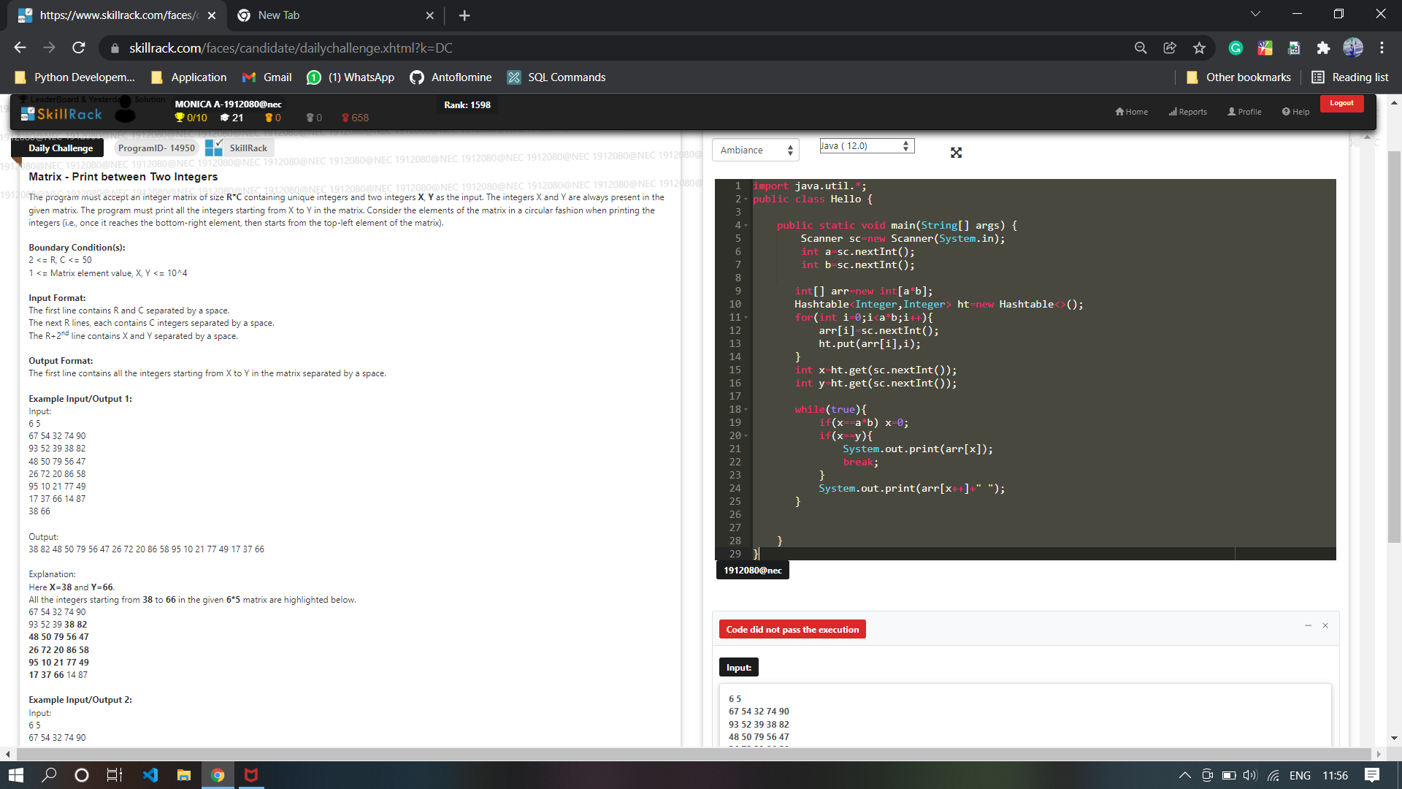

import java.util.\*;

public class Hello {

public static void main(String[] args) {

Scanner sc=new Scanner(System.in);

int a=sc.nextInt();

int b=sc.nextInt();

int[] arr=new int[a\*b];

Hashtable<Integer,Integer> ht=new Hashtable<>();

for(int i=0;i<a\*b;i++){

arr[i]=sc.nextInt();

ht.put(arr[i],i);

}

int x=ht.get(sc.nextInt());

int y=ht.get(sc.nextInt());

while(true){

if(x==a\*b) x=0;

if(x==y){

System.out.print(arr[x]);

break;

}

System.out.print(arr[x++]+" ");

}

}

}

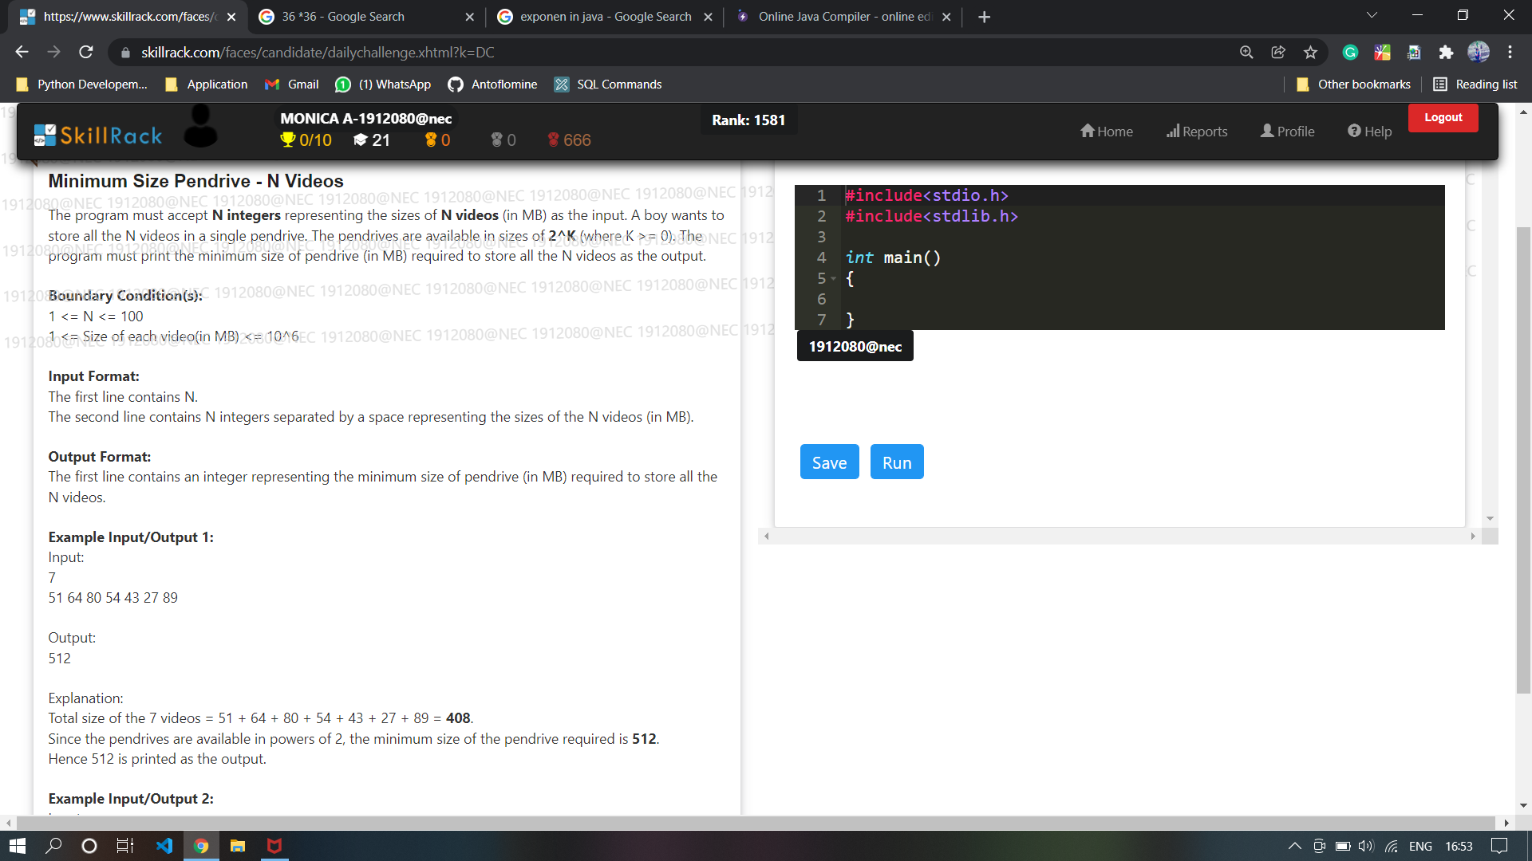

import java.util.\*;

public class Hello {

public static void main(String[] args) {

Scanner sc=new Scanner(System.in);

int N=sc.nextInt();

int[] arr=new int[N];

int sum=0;

for(int i=0;i<N;i++){

arr[i]=sc.nextInt();

sum+=arr[i];

}

int j=1;

while(true){

if(sum<=Math.pow(2,j)){

break;

}

j++;

}

System.out.print((int)Math.pow(2,j));

}

}

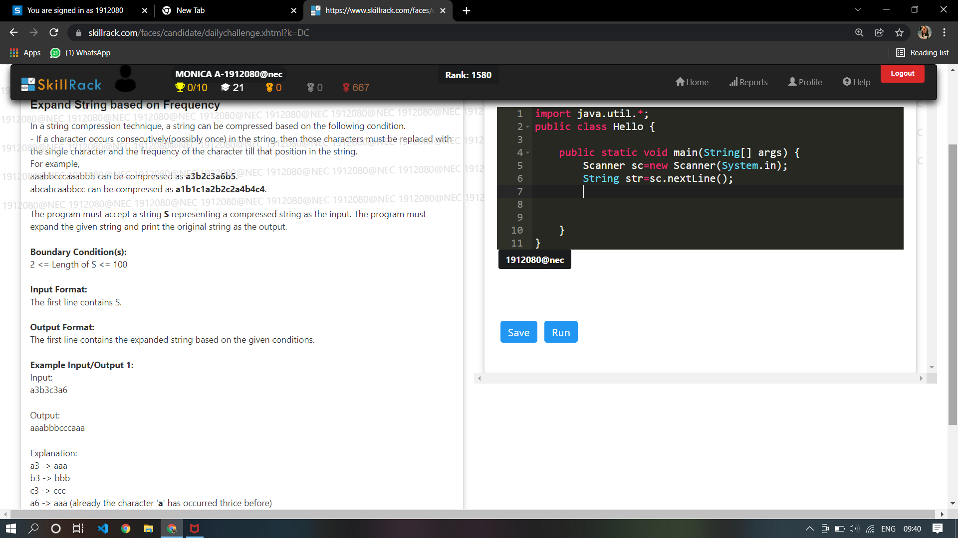

import java.util.\*;

public class Main

{

public static void main(String[] args) {

Scanner sc=new Scanner(System.in);

String[] str=sc.nextLine().split("(?<=\\D)(?=\\d)|(?<=\\d)(?=\\D)");

int[] arr=new int[26];

int[] arr1=new int[26];

for(int i=1;i<str.length;i=i+2){

if(Character.isLowerCase(str[i-1].charAt(0))){

if(arr[str[i-1].charAt(0)-'a']==0){

for(int j=0;j<Integer.parseInt(str[i]);j++){

System.out.print(str[i-1]);

}

arr[str[i-1].charAt(0)-'a']=Integer.parseInt(str[i]);

}

else if( arr[str[i-1].charAt(0)-'a']!=0) {

for(int j=0;j<Integer.parseInt(str[i])-arr[str[i-1].charAt(0)-'a'];j++){

System.out.print(str[i-1]);

}

arr[str[i-1].charAt(0)-'a']=Integer.parseInt(str[i]);

}

}

else{

if(arr1[str[i-1].charAt(0)-'A']==0){

for(int j=0;j<Integer.parseInt(str[i]);j++){

System.out.print(str[i-1]);

}

arr1[str[i-1].charAt(0)-'A']=Integer.parseInt(str[i]);

}

else if( arr1[str[i-1].charAt(0)-'A']!=0) {

for(int j=0;j<Integer.parseInt(str[i])-arr1[str[i-1].charAt(0)-'A'];j++){

System.out.print(str[i-1]);

}

arr1[str[i-1].charAt(0)-'A']=Integer.parseInt(str[i]);

}

}

}

}

}

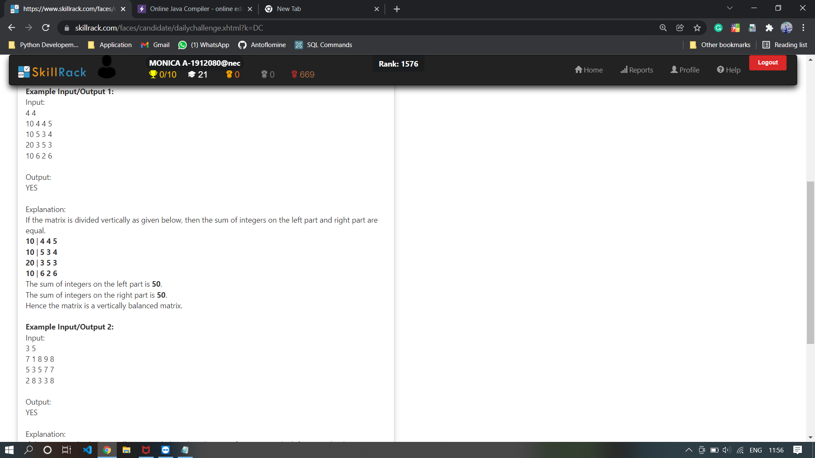

import java.util.\*;

public class Hello {

public static void main(String[] args) {

Scanner sc=new Scanner(System.in);

int r=sc.nextInt();

int c=sc.nextInt();

int mat[][]=new int[r][c];

int left=0,right=0;

int colSum[]=new int[c];

for(int i=0;i<r;i++){

for(int j=0;j<c;j++){

mat[i][j]=sc.nextInt();

colSum[j]+=mat[i][j];

if(j!=0 && j<c) right+=mat[i][j];

}

}

if(colSum[0]==right){

System.out.print("YES");

return;

}

left=colSum[0];

int toSub=1;

while(left!=right){

right-=colSum[toSub];

left+=colSum[toSub];

toSub++;

if(left==right) break;

if(toSub==c){

System.out.print("NO");

return;

}

}

System.out.print("YES");

}

}

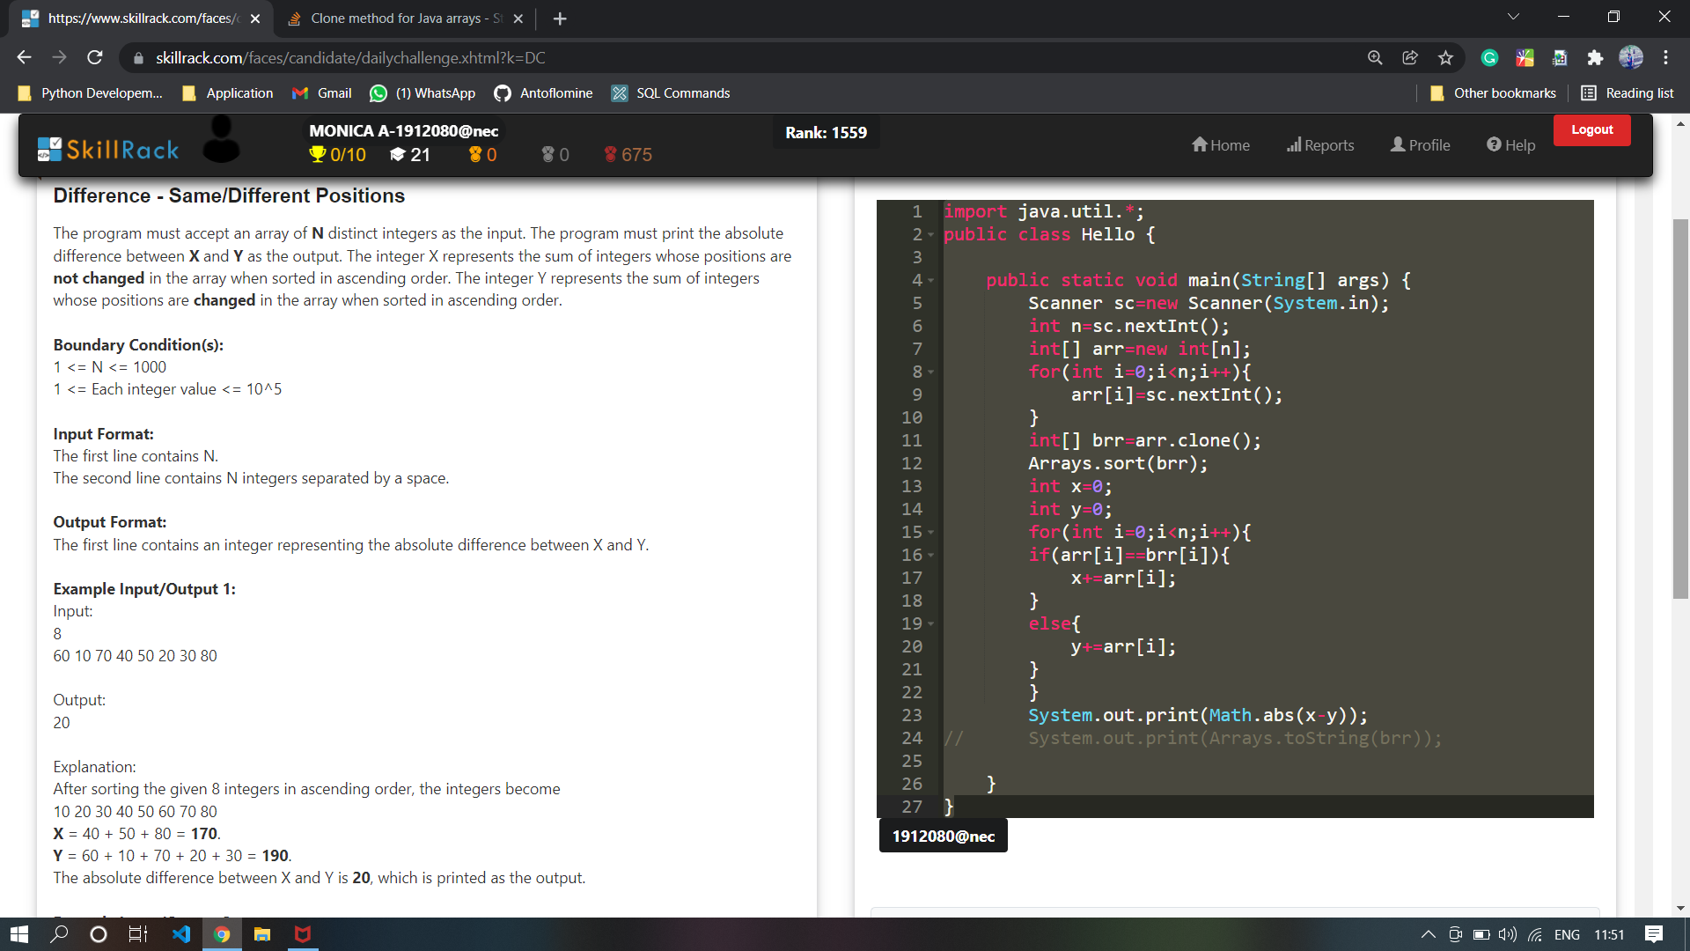

import java.util.\*;

public class Hello {

public static void main(String[] args) {

Scanner sc=new Scanner(System.in);

int n=sc.nextInt();

int[] arr=new int[n];

for(int i=0;i<n;i++){

arr[i]=sc.nextInt();

}

int[] brr=arr.clone();

Arrays.sort(brr);

int x=0;

int y=0;

for(int i=0;i<n;i++){

if(arr[i]==brr[i]){

x+=arr[i];

}

else{

y+=arr[i];

}

}

System.out.print(Math.abs(x-y));

// System.out.print(Arrays.toString(brr));

}

}

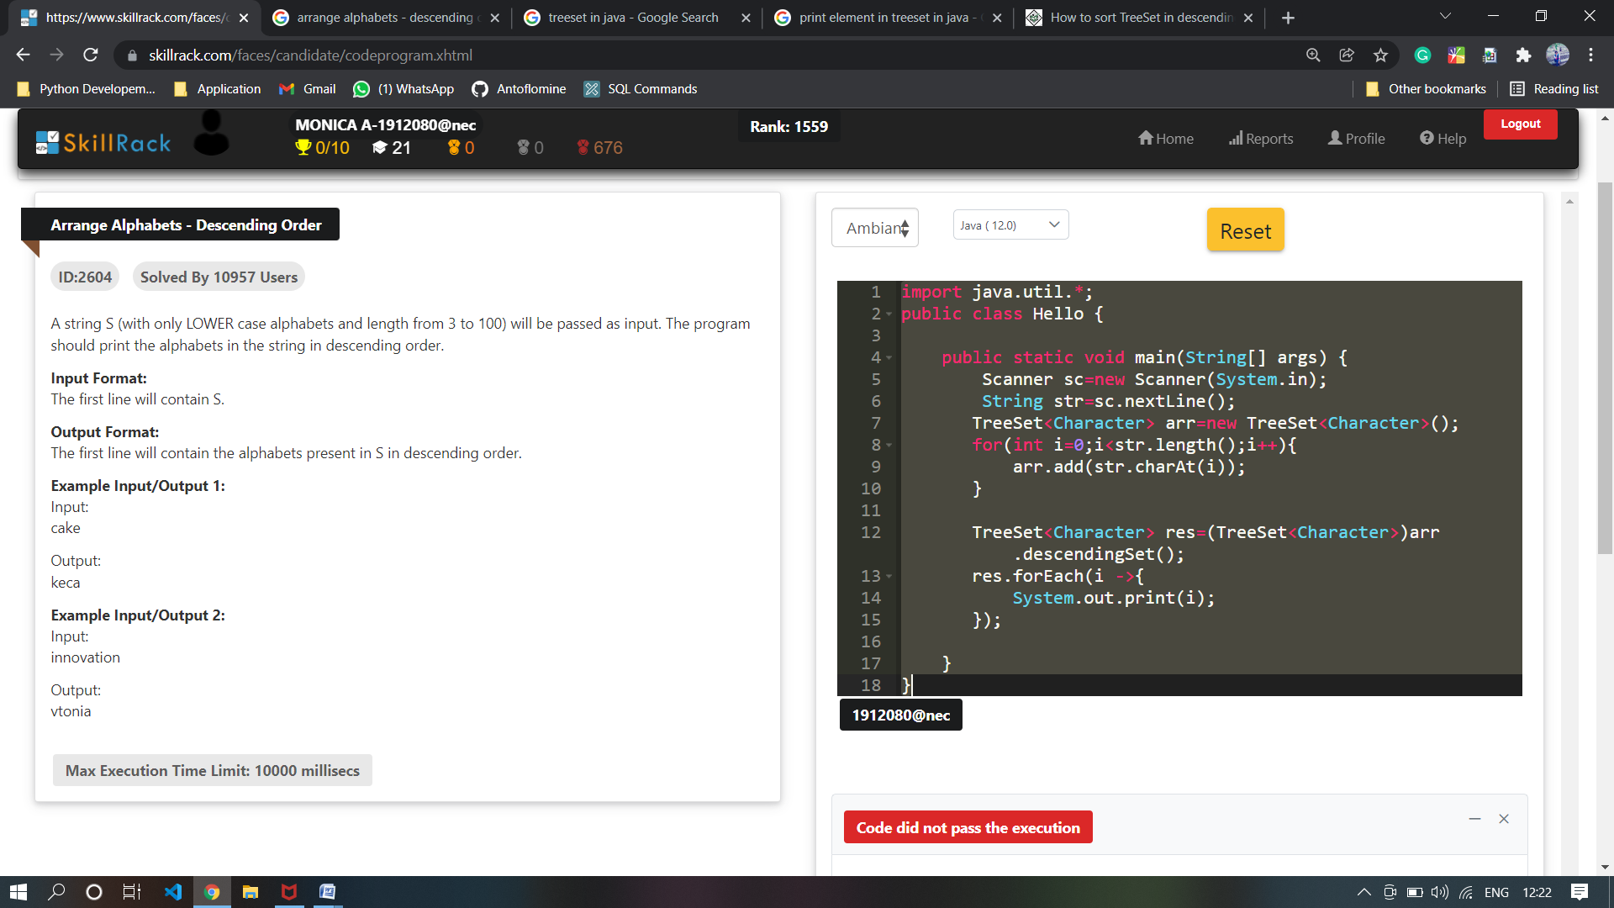

import java.util.\*;

public class Hello {

public static void main(String[] args) {

Scanner sc=new Scanner(System.in);

String str=sc.nextLine();

TreeSet<Character> arr=new TreeSet<Character>();

for(int i=0;i<str.length();i++){

arr.add(str.charAt(i));

}

TreeSet<Character> res=(TreeSet<Character>)arr.descendingSet();

res.forEach(i ->{

System.out.print(i);

});

}

}

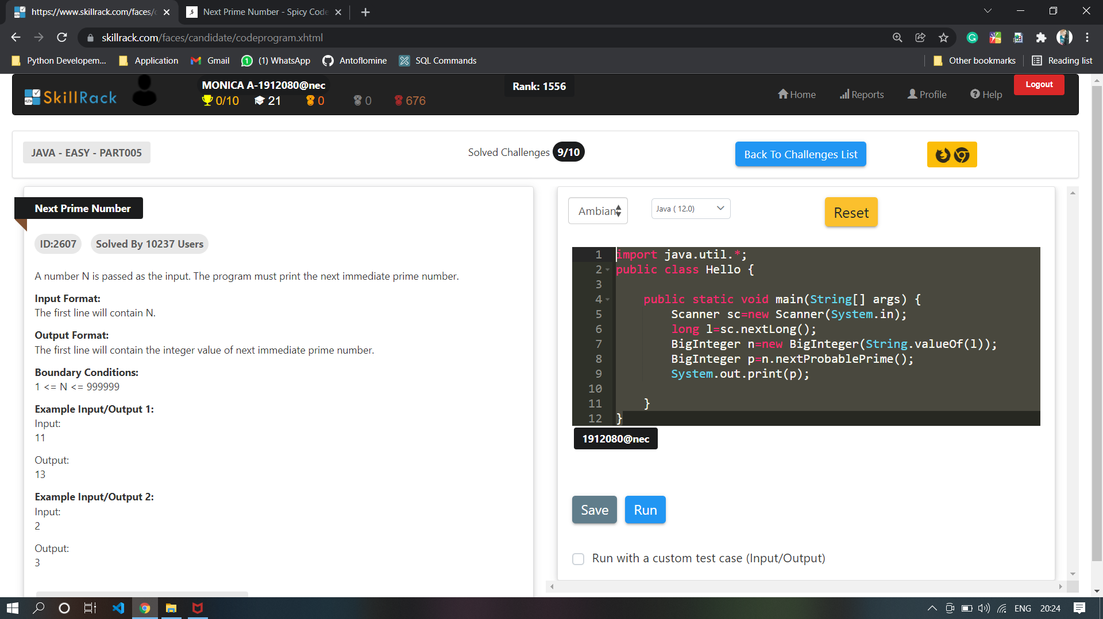

import java.util.\*;

import java.math.\*;

public class Hello {

public static void main(String[] args) {

Scanner sc=new Scanner(System.in);

long l=sc.nextLong();

BigInteger n=new BigInteger(String.valueOf(l));

BigInteger p=n.nextProbablePrime();

System.out.print(p);

}

}

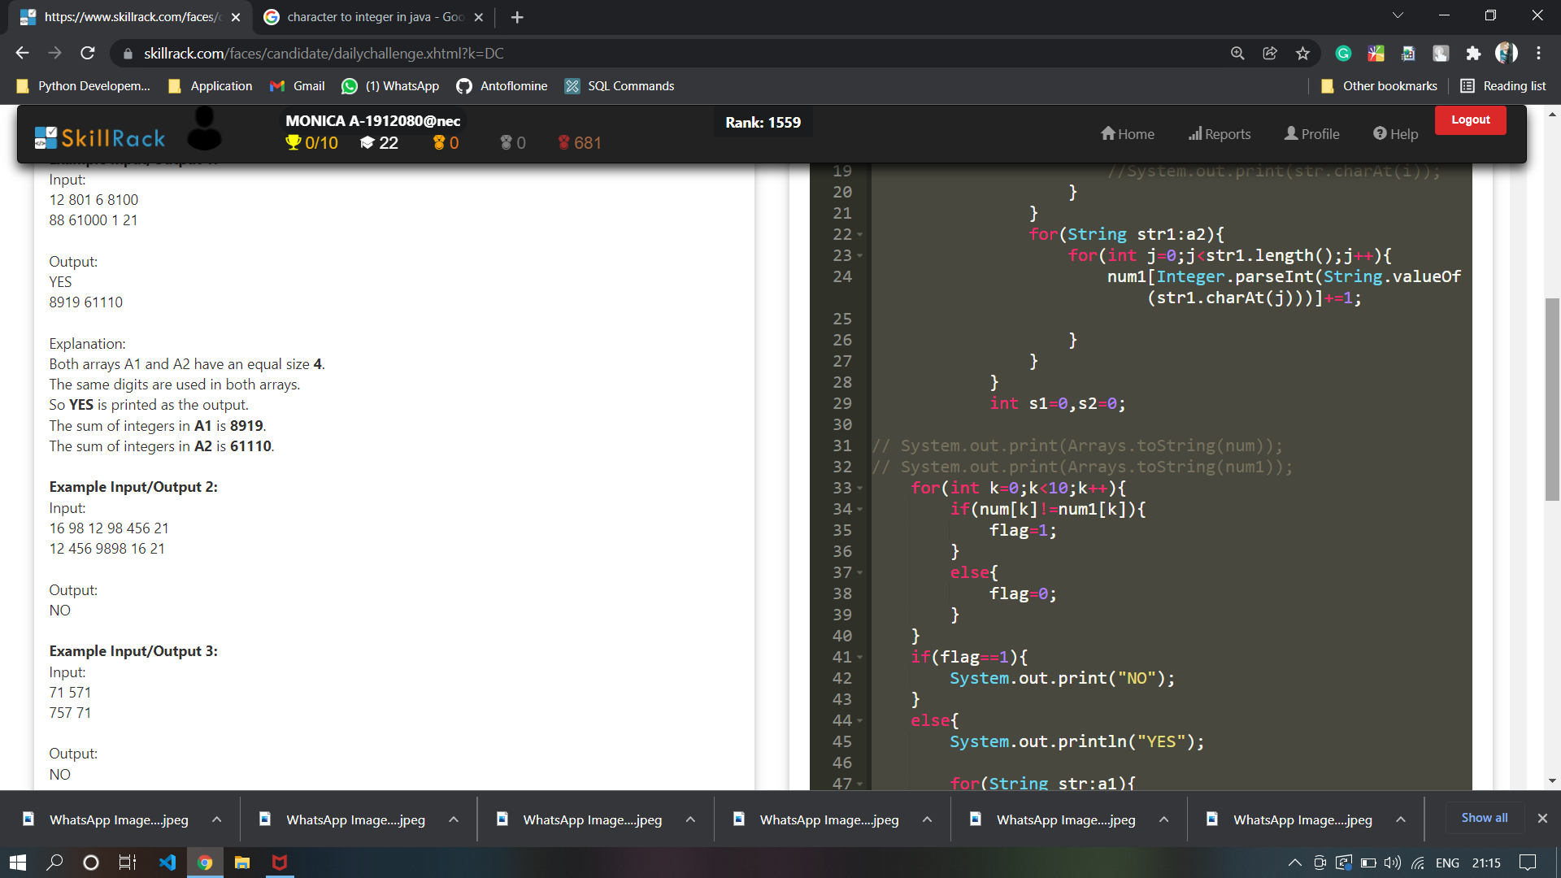

import java.util.\*;

public class Hello {

public static void main(String[] args) {

Scanner sc=new Scanner(System.in);

String str=sc.nextLine();

char[] arr=str.toCharArray();

char toFill='\0';

char curr='\0';

System.out.print(arr[0]);

for(int i=1;i<arr.length;i++){

if(arr[i]==arr[i-1]){

int temp=(int) arr[i];

toFill=(char)(((temp+1-97)%26)+97);

System.out.print(toFill);

curr=arr[i];

arr[i]='A';

continue;

}

if(arr[i]==curr){

int temp=(int)toFill;

toFill=(char)(((temp+1-97)%26)+97);

arr[i]='A';

System.out.print(toFill);

}

else{

System.out.print(arr[i]);

curr='A';

}

}

}

}

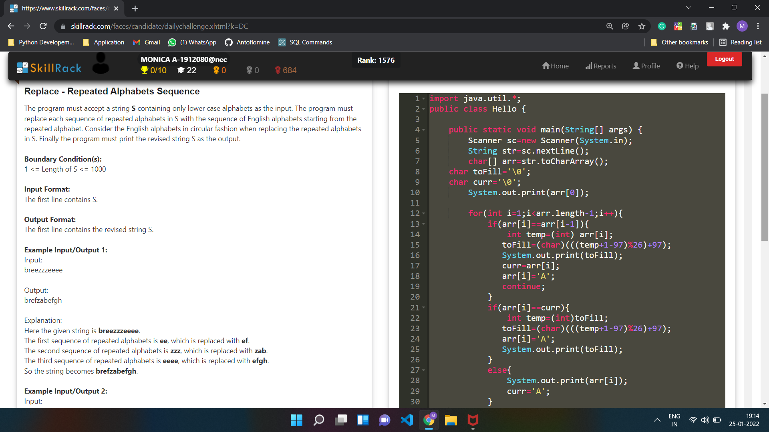

import java.util.\*;

public class Main {

public static void main(String[] args) {

Scanner sc=new Scanner(System.in);

int n=sc.nextInt();

int k=sc.nextInt();

int a=0;

for(int i=k;i<k+n;i++){

if(i%n==0){

a=i;

break;

}

}

// System.out.print(a+" ");

int b=a/n;

//System.out.print(b+" ");

if(b%2==1){

System.out.print(k);

}

else{

if(k%n==0){

System.out.print(a-((n-1)));

}

int l=1;

while(l<=n-1){

if(k%n==l){

//System.out.print(((a-(l-(n-(l-1)))-1)));

System.out.print(a-((l-1)));

System.out.print(l);

}

l++;

}

}

}

}

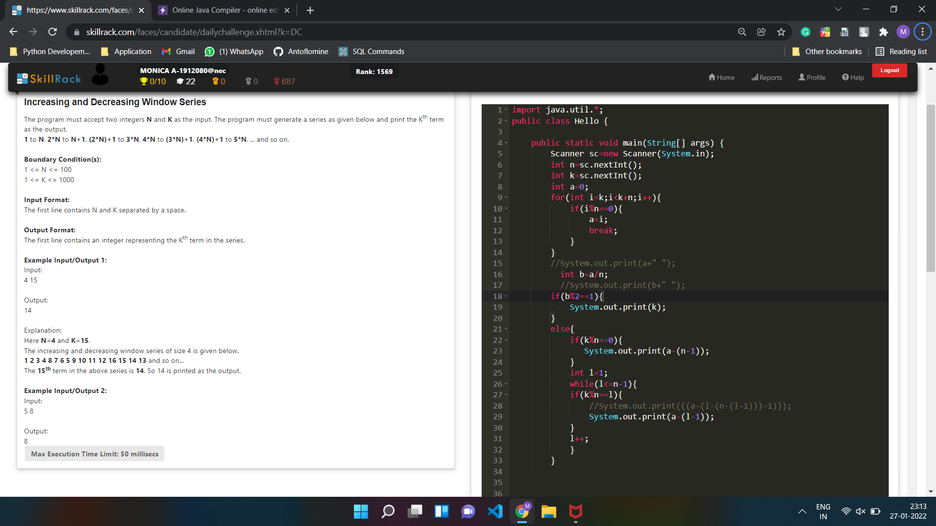

import java.util.\*;

public class Main

{

public static void main(String[] args) {

Scanner sc=new Scanner(System.in);

int tc =sc.nextInt();

int arr[][] = new int[tc][2];

for(int i=0;i<tc;i++){

arr[i][0]=sc.nextInt();

arr[i][1]=sc.nextInt();

}

int wite=0;

while(wite<tc){

//start

int x=arr[wite][0];

int y=arr[wite][1];

int c=1;

System.out.print("[");

for(int l=0;l<x;l++){

System.out.print("[");

for(int m=0;m<y;m++){

if(m==y-1){

System.out.print(c);

c++;

break;

}

System.out.print(c+" ");

c++;

}

System.out.print("]");

}

System.out.print("]");

//end

System.out.println();

wite++;

}

}

}

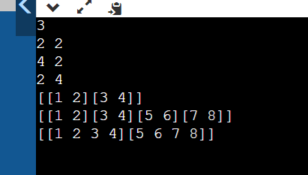

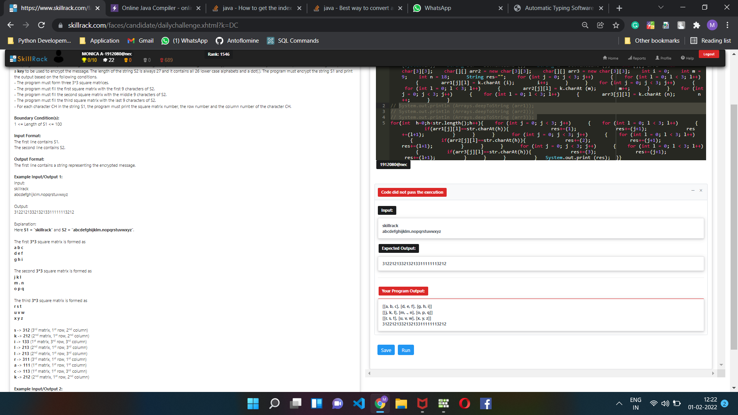

import java.util.\*;

public class Main

{

public static void main (String[]args)

{

Scanner sc = new Scanner (System.in);

String str = sc.nextLine ();

String k = sc.nextLine ();

char[][] arr1 = new char[3][3];

char[][] arr2 = new char[3][3];

char[][] arr3 = new char[3][3];

int i = 0;

int m = 9;

int n = 18;

String res="";

for (int j = 0; j < 3; j++)

{

for (int l = 0; l < 3; l++)

{

arr1[j][l] = k.charAt (i);

i++;

}

}

for (int j = 0; j < 3; j++)

{

for (int l = 0; l < 3; l++)

{

arr2[j][l] = k.charAt (m);

m++;

}

}

for (int j = 0; j < 3; j++)

{

for (int l = 0; l < 3; l++)

{

arr3[j][l] = k.charAt (n);

n++;

}

}

System.out.println (Arrays.deepToString (arr1));

System.out.println (Arrays.deepToString (arr2));

System.out.println (Arrays.deepToString (arr3));

for(int h=0;h<str.length();h++){

for (int j = 0; j < 3; j++)

{

for (int l = 0; l < 3; l++)

{

if(arr1[j][l]==str.charAt(h)){

res+=(1);

res+=(j+1);

res+=(l+1);

}

}

}

for (int j = 0; j < 3; j++)

{

for (int l = 0; l < 3; l++)

{

if(arr2[j][l]==str.charAt(h)){

res+=(2);

res+=(j+1);

res+=(l+1);

}

}

}

for (int j = 0; j < 3; j++)

{

for (int l = 0; l < 3; l++)

{

if(arr3[j][l]==str.charAt(h)){

res+=(3);

res+=(j+1);

res+=(l+1);

}

}

}

}

System.out.print (res);

}

}

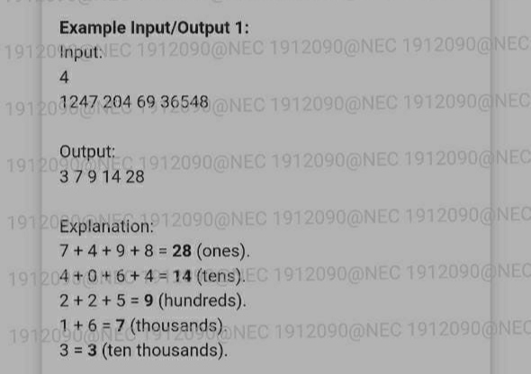

import java.util.\*;

public class Main

{

public static void main(String[] args) {

Scanner sc=new Scanner(System.in);

int n=sc.nextInt();

int[] arr=new int[n];

String[] arr1=new String[n];

for(int i=0;i<n;i++){

arr[i]=sc.nextInt();

// arr1[i]=String.valueOf(arr[i]);

}

Arrays.sort(arr);

// System.out.println(Arrays.toString(arr));

// System.out.println(Arrays.toString(arr1));

int last=arr[arr.length-1];

int len=Integer.toString(last).length();

// System.out.println(len);

for(int i=0;i<n;i++){

String q=String.format("%05d",arr[i]);

arr1[i]=q;

}

// System.out.println(Arrays.toString(arr1));

for(int j=len-1;j>=0;j--){

int sum=0;

for(int k=0;k<n;k++){

sum+=Character.getNumericValue(arr1[k].charAt(j));

}

System.out.println(sum);

}

}

}

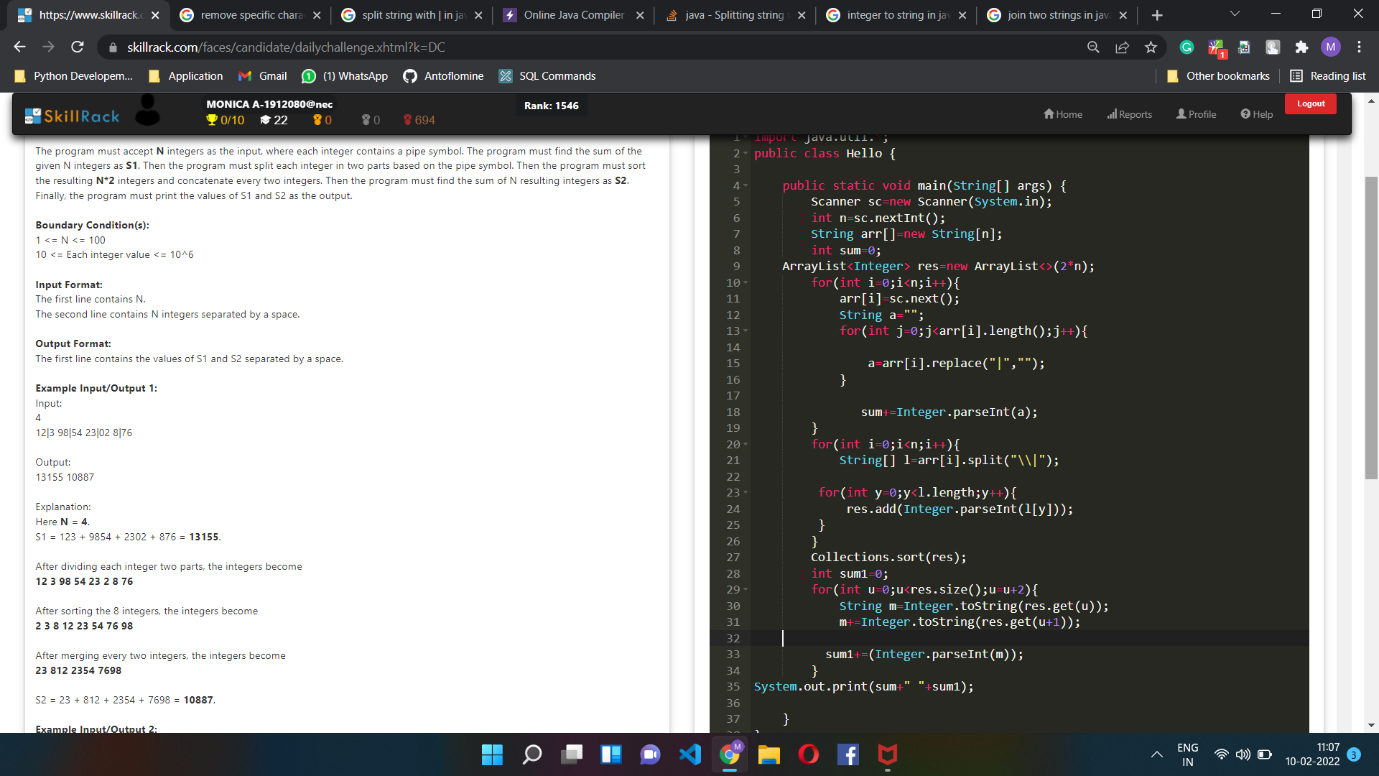

import java.util.\*;

public class Main {

public static void main(String[] args) {

Scanner sc=new Scanner(System.in);

int n=sc.nextInt();

String arr[]=new String[n];

int sum=0;

ArrayList<Integer> res=new ArrayList<>(2\*n);

for(int i=0;i<n;i++){

arr[i]=sc.next();

String a="";

for(int j=0;j<arr[i].length();j++){

a=arr[i].replace("|","");

}

sum+=Integer.parseInt(a);

}

for(int i=0;i<n;i++){

String[] l=arr[i].split("\\|");

for(int y=0;y<l.length;y++){

res.add(Integer.parseInt(l[y]));

}

}

Collections.sort(res);

int sum1=0;

for(int u=0;u<res.size();u=u+2){

String m=Integer.toString(res.get(u));

m+=Integer.toString(res.get(u+1));

sum1+=(Integer.parseInt(m));

}

System.out.print(sum+" "+sum1);

}

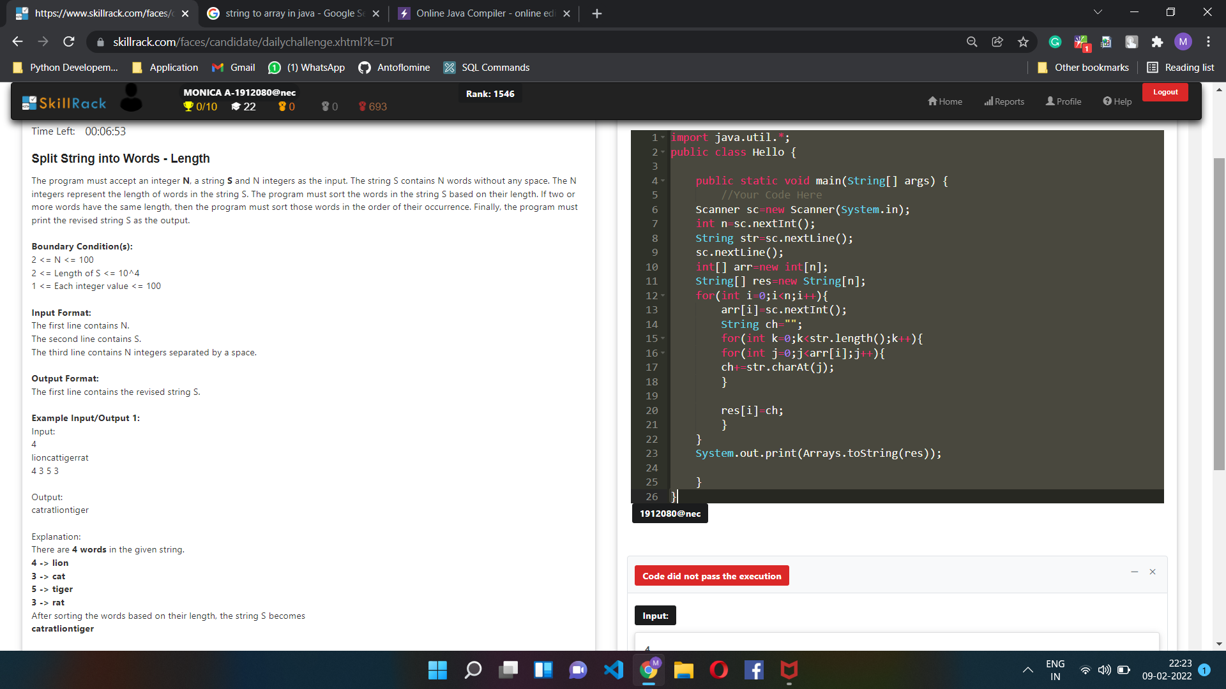

/\*\*\*\*\*\*\*\*\*\*\*\*\*\*\*\*\*\*\*\*\*\*\*\*\*\*\*\*\*\*\*\*\*\*\*\*\*\*\*\*\*\*\*\*\*\*\*\*\*\*\*\*\*\*\*\*\*\*\*\*\*\*\*\*\*\*\*\*\*\*\*\*\*\*\*\*\*\*

Online Java Compiler.

Code, Compile, Run and Debug java program online.

Write your code in this editor and press "Run" button to execute it.

\*\*\*\*\*\*\*\*\*\*\*\*\*\*\*\*\*\*\*\*\*\*\*\*\*\*\*\*\*\*\*\*\*\*\*\*\*\*\*\*\*\*\*\*\*\*\*\*\*\*\*\*\*\*\*\*\*\*\*\*\*\*\*\*\*\*\*\*\*\*\*\*\*\*\*\*\*\*\*/

import java.util.\*;

public class Main

{

public static void main(String[] args) {

int n=4;

String str="lioncattigerrat";

int[] arr=new int[]{4,3,5,3};

String[] res=new String[n];

String s1="";

//ArrayList<String> res=new ArrayList<>();

int y=0;

for(int j=0,i=0;j<arr.length &i<n;j++,i++){

String a=str.substring(y,y+arr[j]);

// res.add(a);

res[i]=a;

y+=arr[j];

}

// System.out.println(res);

System.out.println(Arrays.toString(res));

Arrays.sort(arr);

for(int i=0;i<n;i++)

{

for(int j=0;j<n;j++)

{

if(res[j].length()==arr[i])

{

if(s1.contains(res[j]))

{

continue;

}

else

s1=s1+res[j];

break;

}

}

}

System.out.println(s1);

}

}

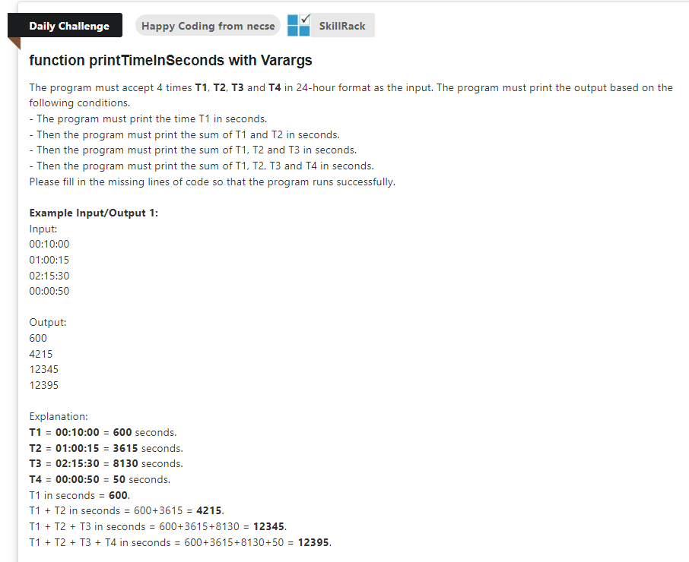

import java.util.\*;

public class Main

{

public static void main(String[] args) {

Scanner sc=new Scanner(System.in);

int n=4;

String[] arr=new String[n];

int sum=0;

for(int i=0;i<n;i++){

arr[i]=sc.next();

String[] s=arr[i].split(":");

sum+=(Integer.parseInt(s[0])\*60\*60);

sum+=(Integer.parseInt(s[1])\*60);

sum+=Integer.parseInt(s[2]);

System.out.println(sum);

}

}

}

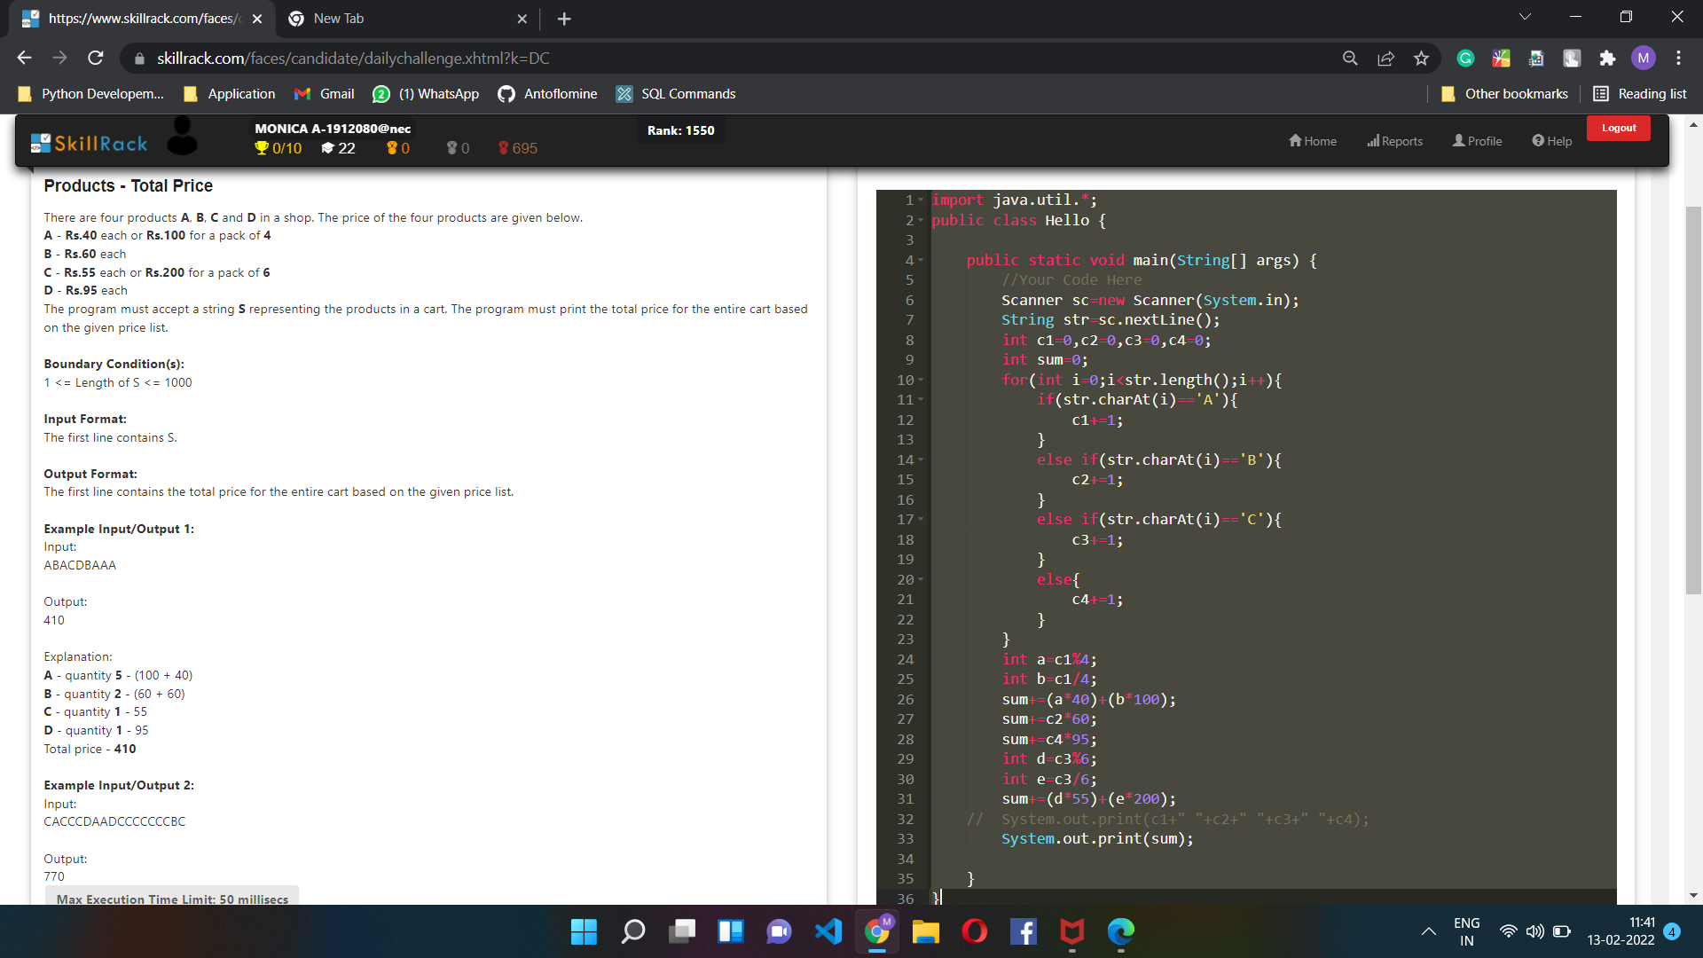

import java.util.\*;

public class Hello {

public static void main(String[] args) {

//Your Code Here

Scanner sc=new Scanner(System.in);

String str=sc.nextLine();

int c1=0,c2=0,c3=0,c4=0;

int sum=0;

for(int i=0;i<str.length();i++){

if(str.charAt(i)=='A'){

c1+=1;

}

else if(str.charAt(i)=='B'){

c2+=1;

}

else if(str.charAt(i)=='C'){

c3+=1;

}

else{

c4+=1;

}

}

int a=c1%4;

int b=c1/4;

sum+=(a\*40)+(b\*100);

sum+=c2\*60;

sum+=c4\*95;

int d=c3%6;

int e=c3/6;

sum+=(d\*55)+(e\*200);

// System.out.print(c1+" "+c2+" "+c3+" "+c4);

System.out.print(sum);

}

}

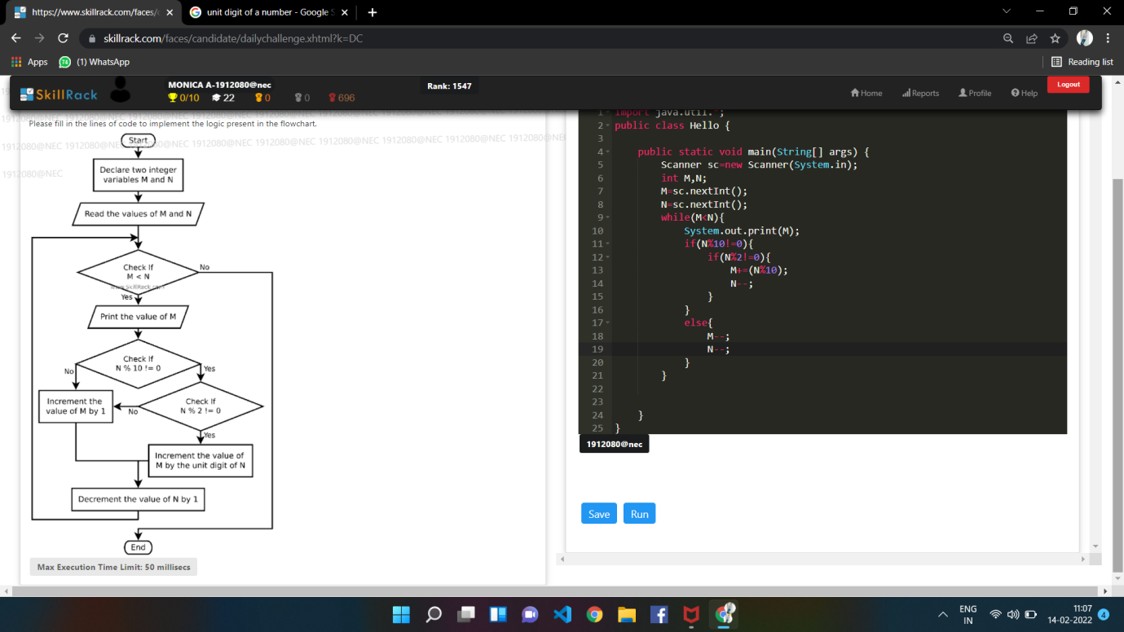

import java.util.\*;

public class Hello {

public static void main(String[] args) {

Scanner sc=new Scanner(System.in);

int M,N;

M=sc.nextInt();

N=sc.nextInt();

while(M<N){

System.out.print(M+" ");

if(N%10!=0){

if(N%2!=0){

M=M+(N%10);

N--;

}

else{

M++;

N--;

}

}

else{

M++;

N--;

}

}

}

}

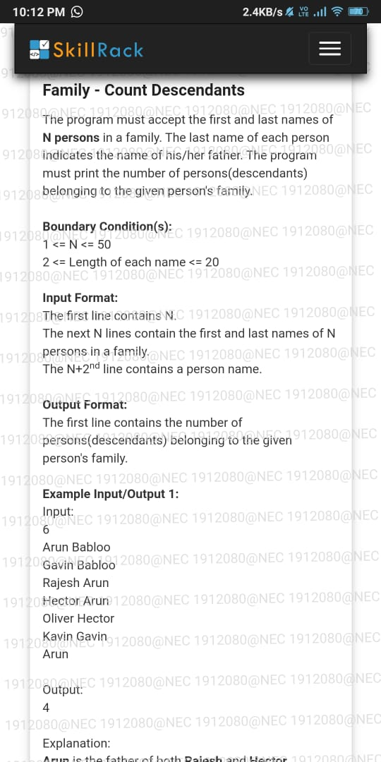

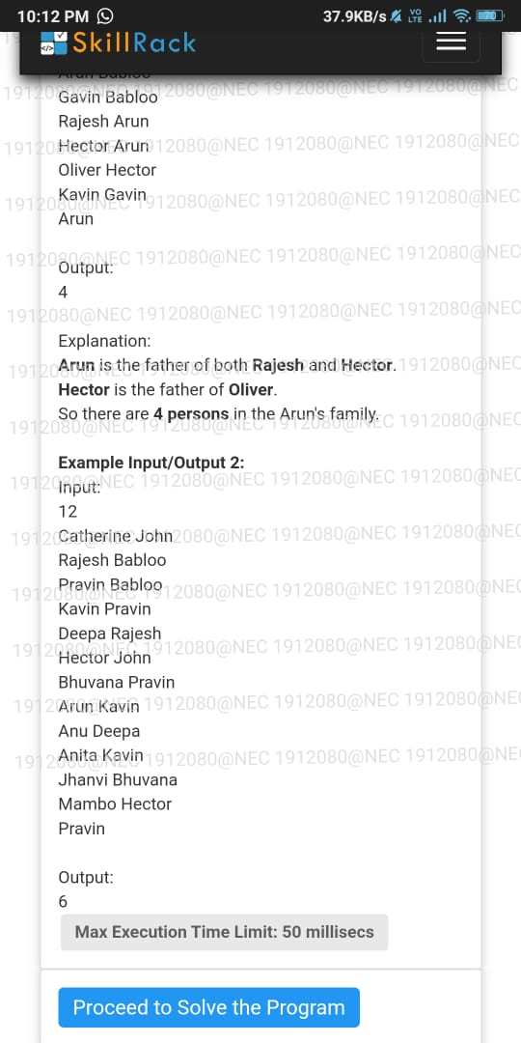

import java.util.\*;

public class Main

{

public static void main(String[] args) {

Scanner sc=new Scanner(System.in);

int n=6;

String[][] arr=new String[n][2];

for(int i=0;i<n;i++){

arr[i][0]=sc.next();

arr[i][1]=sc.next();

}

// System.out.println(Arrays.deepToString(arr));

sc.nextLine();

String a=sc.nextLine();

ArrayList<String> res=new ArrayList<>();

res.add(a);

//System.out.println(a);

int j=0;

while(j<res.size()){

for(int i=0;i<n;i++){

if(arr[i][1].equals(res.get(j))){

res.add(arr[i][0]);

}

}

j++;

}

System.out.println(res.size());

}

}

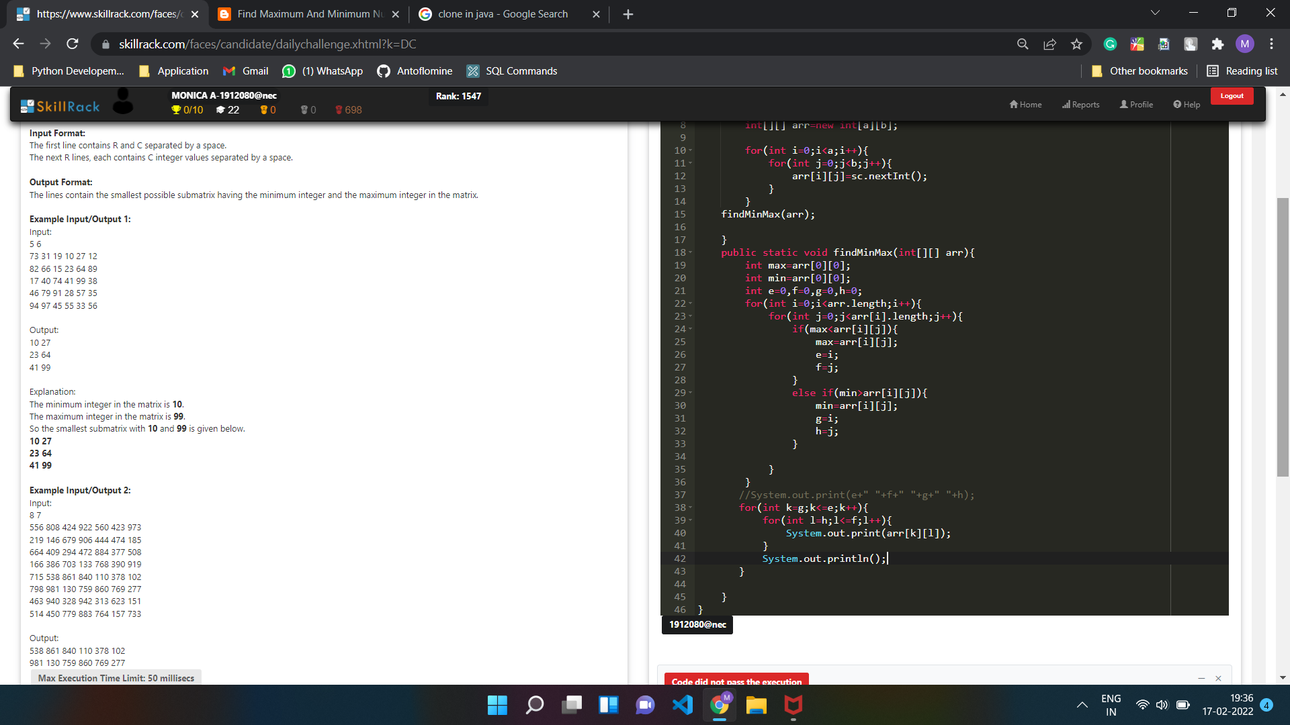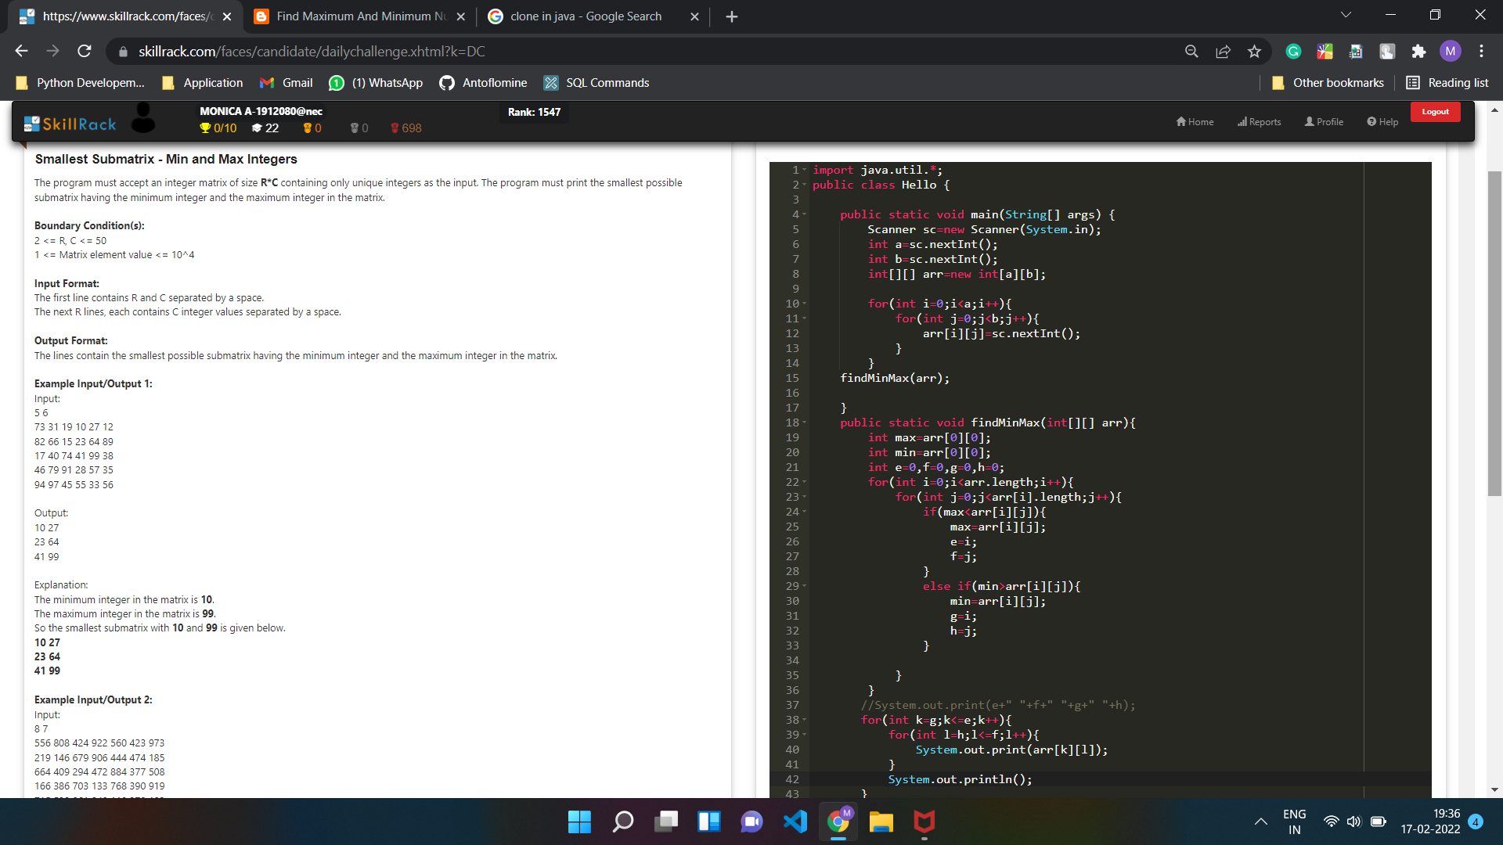

import java.util.\*;

public class Main {

public static void main(String[] args) {

Scanner sc=new Scanner(System.in);

int a=sc.nextInt();

int b=sc.nextInt();

int[][] arr=new int[a][b];

for(int i=0;i<a;i++){

for(int j=0;j<b;j++){

arr[i][j]=sc.nextInt();

}

}

findMinMax(arr);

}

public static void findMinMax(int[][] arr){

int max=arr[0][0];

int min=arr[0][0];

int e=0,f=0,g=0,h=0;

for(int i=0;i<arr.length;i++){

for(int j=0;j<arr[i].length;j++){

if(max<arr[i][j]){

max=arr[i][j];

e=i;

f=j;

}

else if(min>arr[i][j]){

min=arr[i][j];

g=i;

h=j;

}

}

}

//System.out.print(e+" "+f+" "+g+" "+h);

if(h<=f && g<e){

for(int k=g;k<=e;k++){

for(int l=h;l<=f;l++){

System.out.print(arr[k][l]+" ");

}

System.out.println();

}

}

else if(h>f && g<e){

for(int k=g;k<=e;k++){

for(int l=f;l<=h;l++){

System.out.print(arr[k][l]+" ");

}

System.out.println();

}

}

else if(h>f && g>e){

for(int k=e;k<=g;k++){

for(int l=f;l<=h;l++){

System.out.print(arr[k][l]+" ");

}

System.out.println();

}

}

else if(h<=f && g>e){

for(int k=e;k<=g;k++){

for(int l=h;l<=f;l++){

System.out.print(arr[k][l]+" ");

}

System.out.println();

}

}

else if(g==e && h>f){

for(int l=f;l<=h;l++){

System.out.print(arr[g][l]+" ");

}

System.out.println();

}

else if(g==e && h<=f){

for(int l=h;l<=f;l++){

System.out.print(arr[g][l]+" ");

}

System.out.println();

}

}

}

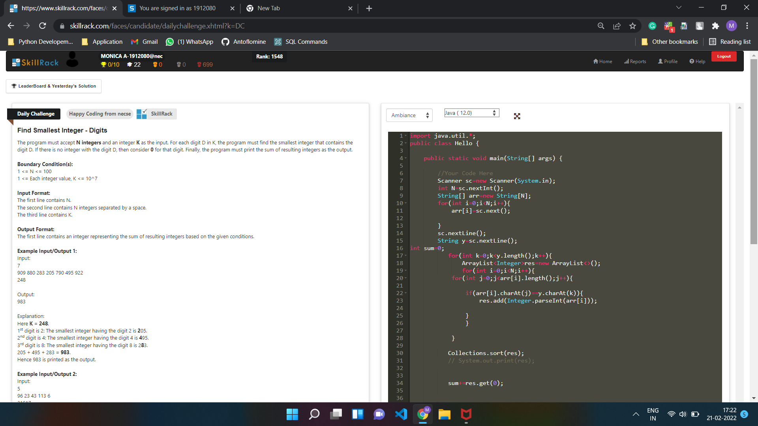

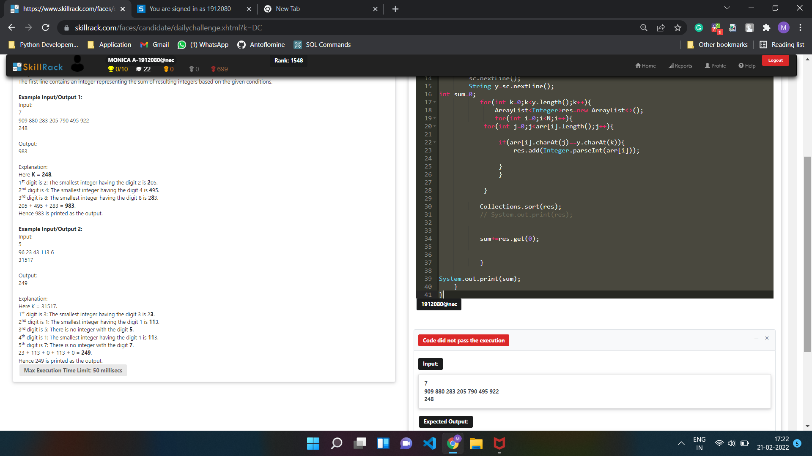

import java.util.\*;

public class Hello {

public static void main(String[] args) {

//Your Code Here

Scanner sc=new Scanner(System.in);

int N=sc.nextInt();

String[] arr=new String[N];

for(int i=0;i<N;i++){

arr[i]=sc.next();

}

sc.nextLine();

String y=sc.nextLine();

int sum=0;

for(int k=0;k<y.length();k++){

ArrayList<Integer>res=new ArrayList<>();

for(int i=0;i<N;i++){

for(int j=0;j<arr[i].length();j++){

if(arr[i].charAt(j)==y.charAt(k)){

res.add(Integer.parseInt(arr[i]));

}

}

}

Collections.sort(res);

int[] ans=new int[res.size()];

Arrays.setAll(ans,res::get);

if(ans.length==0){

continue;

}

else{

sum+=ans[0];

}

//System.out.print(ans[0]);

}

System.out.print(sum);

}

}

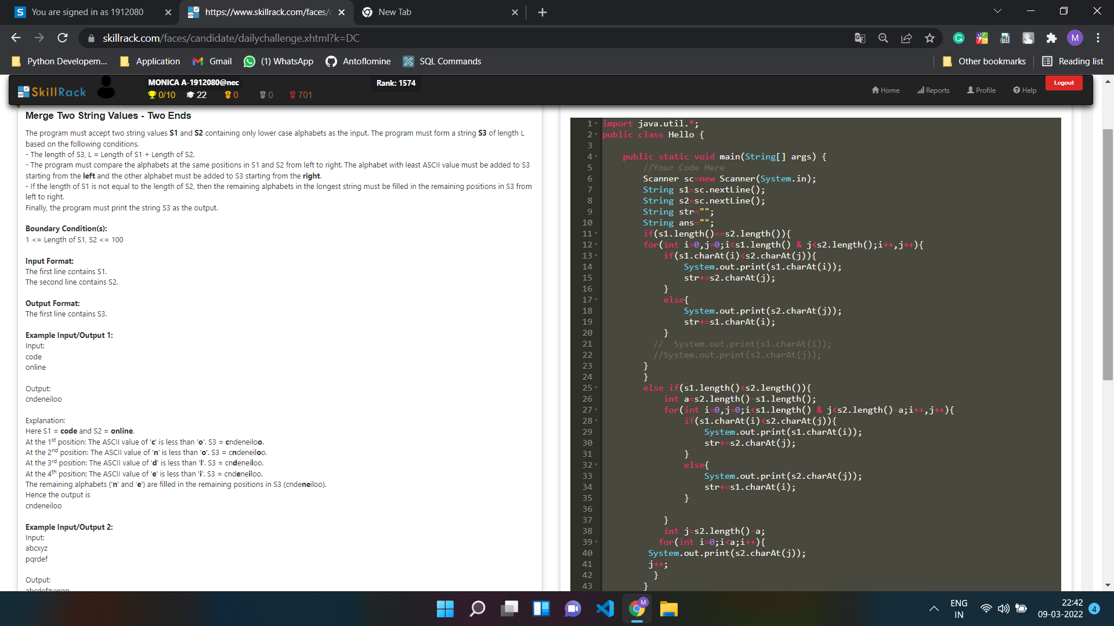

import java.util.\*;

public class Main {

public static void main(String[] args) {

//Your Code Here

Scanner sc=new Scanner(System.in);

String s1=sc.nextLine();

String s2=sc.nextLine();

String str="";

String ans="";

if(s1.length()==s2.length()){

for(int i=0,j=0;i<s1.length() & j<s2.length();i++,j++){

if(s1.charAt(i)<s2.charAt(j)){

System.out.print(s1.charAt(i));

str+=s2.charAt(j);

}

else{

System.out.print(s2.charAt(j));

str+=s1.charAt(i);

}

// System.out.print(s1.charAt(i));

//System.out.print(s2.charAt(j));

}

}

else if(s1.length()<s2.length()){

int a=s2.length()-s1.length();

for(int i=0,j=0;i<s1.length() & j<s2.length()-a;i++,j++){

if(s1.charAt(i)<s2.charAt(j)){

System.out.print(s1.charAt(i));

str+=s2.charAt(j);

}

else{

System.out.print(s2.charAt(j));

str+=s1.charAt(i);

}

}

int j=s2.length()-a;

for(int i=0;i<a;i++){

System.out.print(s2.charAt(j));

j++;

}

}

else{

int a=s1.length()-s2.length();

for(int i=0,j=0;i<s1.length()-a & j<s2.length();i++,j++){

if(s1.charAt(i)>s2.charAt(j)){

System.out.print(s2.charAt(j));

str+=s1.charAt(i);

}

else{

System.out.print(s1.charAt(i));

str+=s2.charAt(j);

}

}

int j=s1.length()-a;

for(int i=0;i<a;i++){

System.out.print(s1.charAt(j));

j++;

}

}

String b=new StringBuilder(str).reverse().toString();

System.out.print(b);

}

}

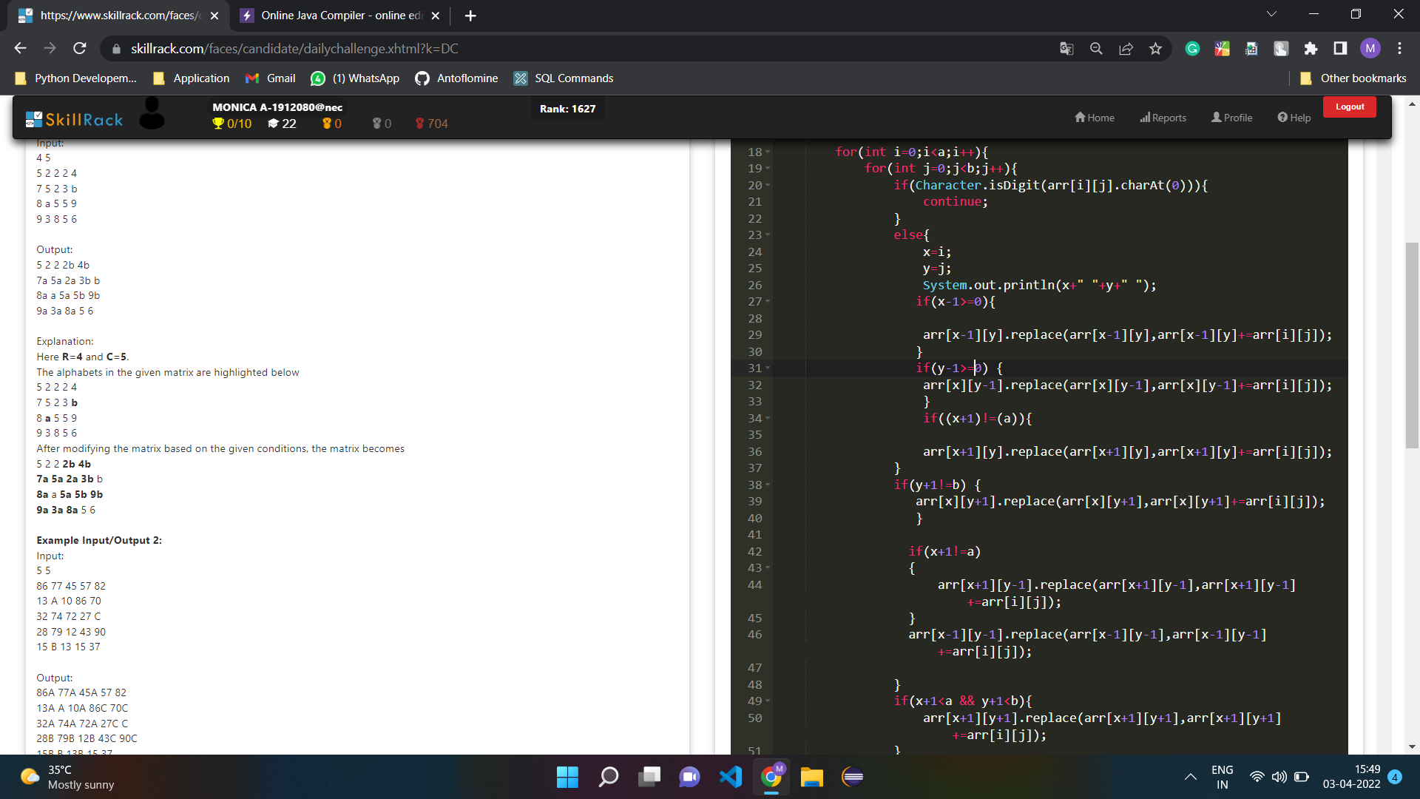

import java.util.\*;

public class Hello {

public static void main(String[] args) {

//Your Code Here

Scanner sc=new Scanner(System.in);

int a=sc.nextInt();

int b=sc.nextInt();

String[][] arr=new String[a][b];

for(int i=0;i<a;i++){

for(int j=0;j<b;j++){

arr[i][j]=sc.next();

}

}

int x=0,y=0;

for(int i=0;i<a;i++){

for(int j=0;j<b;j++){

if(Character.isDigit(arr[i][j].charAt(0))){

continue;

}

else{

x=i;

y=j;

//System.out.println(x+" "+y+" ");

if(x-1>=0){

arr[x-1][y].replace(arr[x-1][y],arr[x-1][y]+=arr[i][j]);

}

if(y-1>=0) {

arr[x][y-1].replace(arr[x][y-1],arr[x][y-1]+=arr[i][j]);

}

if((x+1)<(a)){

arr[x+1][y].replace(arr[x+1][y],arr[x+1][y]+=arr[i][j]);

}

if(y+1<b) {

arr[x][y+1].replace(arr[x][y+1],arr[x][y+1]+=arr[i][j]);

}

if(x+1<a && y-1>=0)

{

arr[x+1][y-1].replace(arr[x+1][y-1],arr[x+1][y-1]+=arr[i][j]);

}

if(x-1>=0 && y-1>=0){

arr[x-1][y-1].replace(arr[x-1][y-1],arr[x-1][y-1]+=arr[i][j]);

}

}

if(x+1<a && y+1<b){

arr[x+1][y+1].replace(arr[x+1][y+1],arr[x+1][y+1]+=arr[i][j]);

}

if(y+1<b && x-1>=0){

arr[x-1][y+1].replace(arr[x-1][y+1],arr[x-1][y+1]+=arr[i][j]);

}

}

}

for(int i=0;i<a;i++){

for(int j=0;j<b;j++){

System.out.print(arr[i][j]+" ");

}

System.out.println();

}

}

}

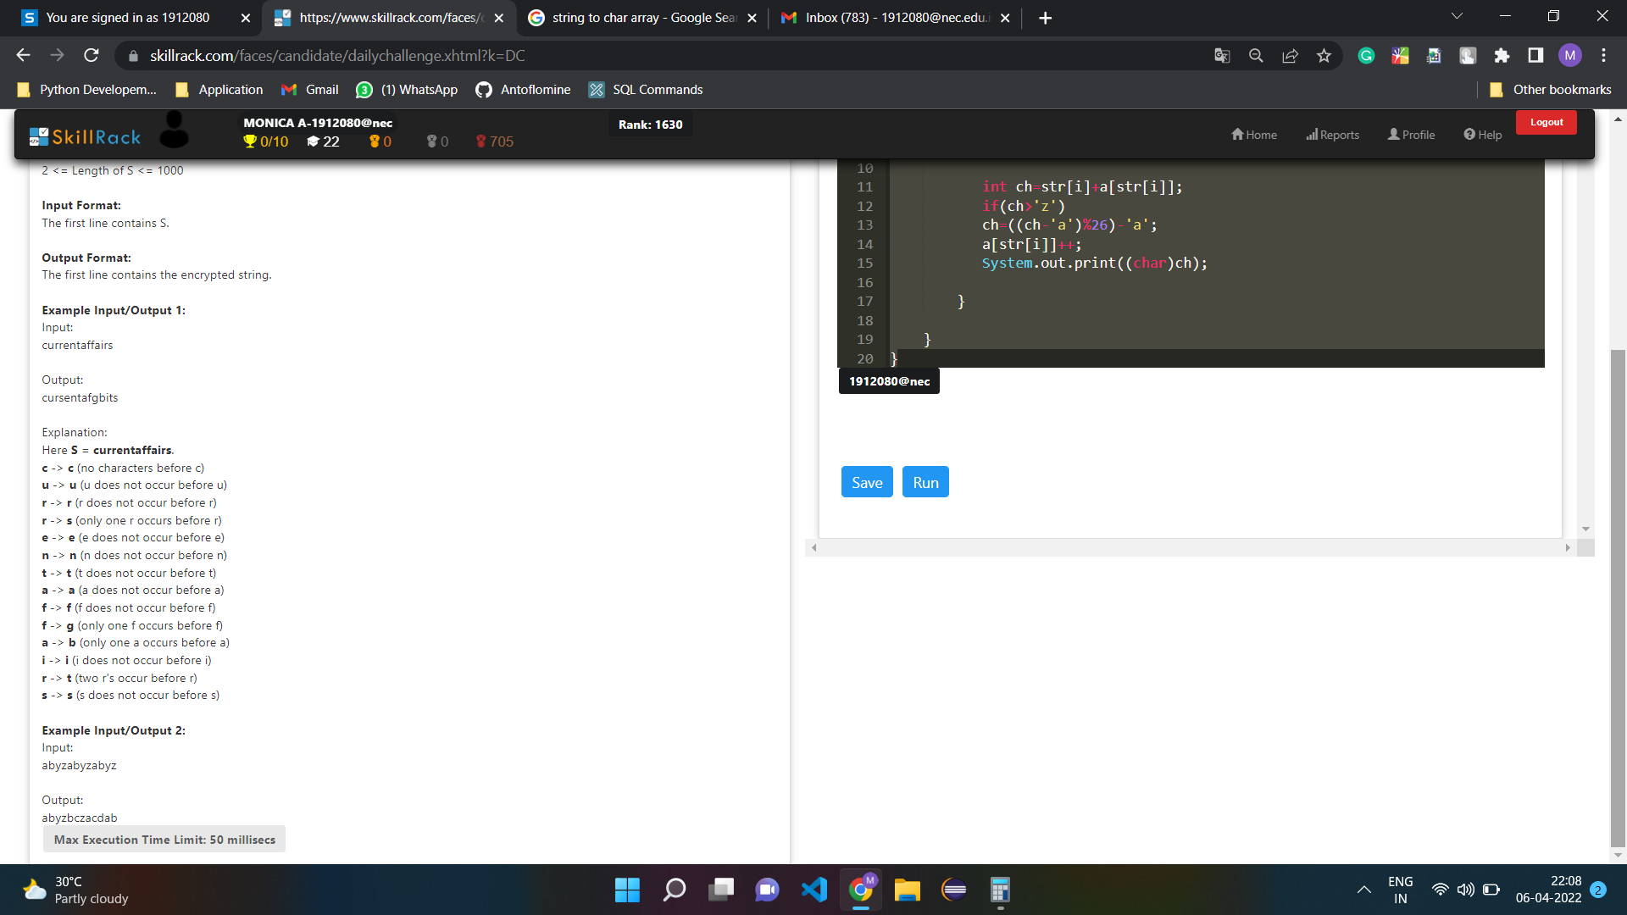

import java.util.\*;

public class Hello {

public static void main(String[] args) {

Scanner sc=new Scanner(System.in);

char[] str=sc.next().toCharArray();

int[] a=new int[256];

for(int i=0;i<str.length;i++){

int ch=str[i]+a[str[i]];

if(ch>'z')

ch=((ch-'a')%26)+'a';

a[str[i]]++;

System.out.print((char)ch);

}

}

}

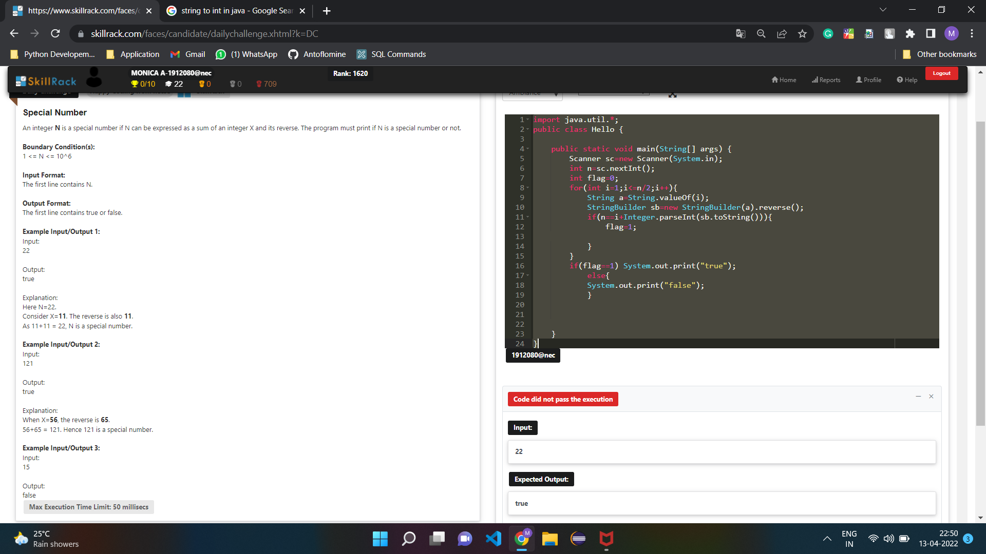

import java.util.\*;

public class Hello {

public static void main(String[] args) {

Scanner sc=new Scanner(System.in);

int n=sc.nextInt();

int flag=0;

for(int i=1;i<n;i++){

String a=String.valueOf(i);

StringBuilder sb=new StringBuilder(a).reverse();

if(n==i+Integer.parseInt(sb.toString())){

flag=1;

}

}

if(flag==1) System.out.print("true");

else{

System.out.print("false");

}

}

}

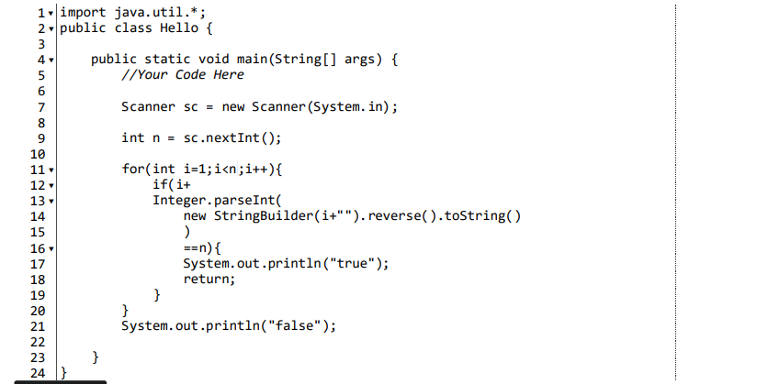

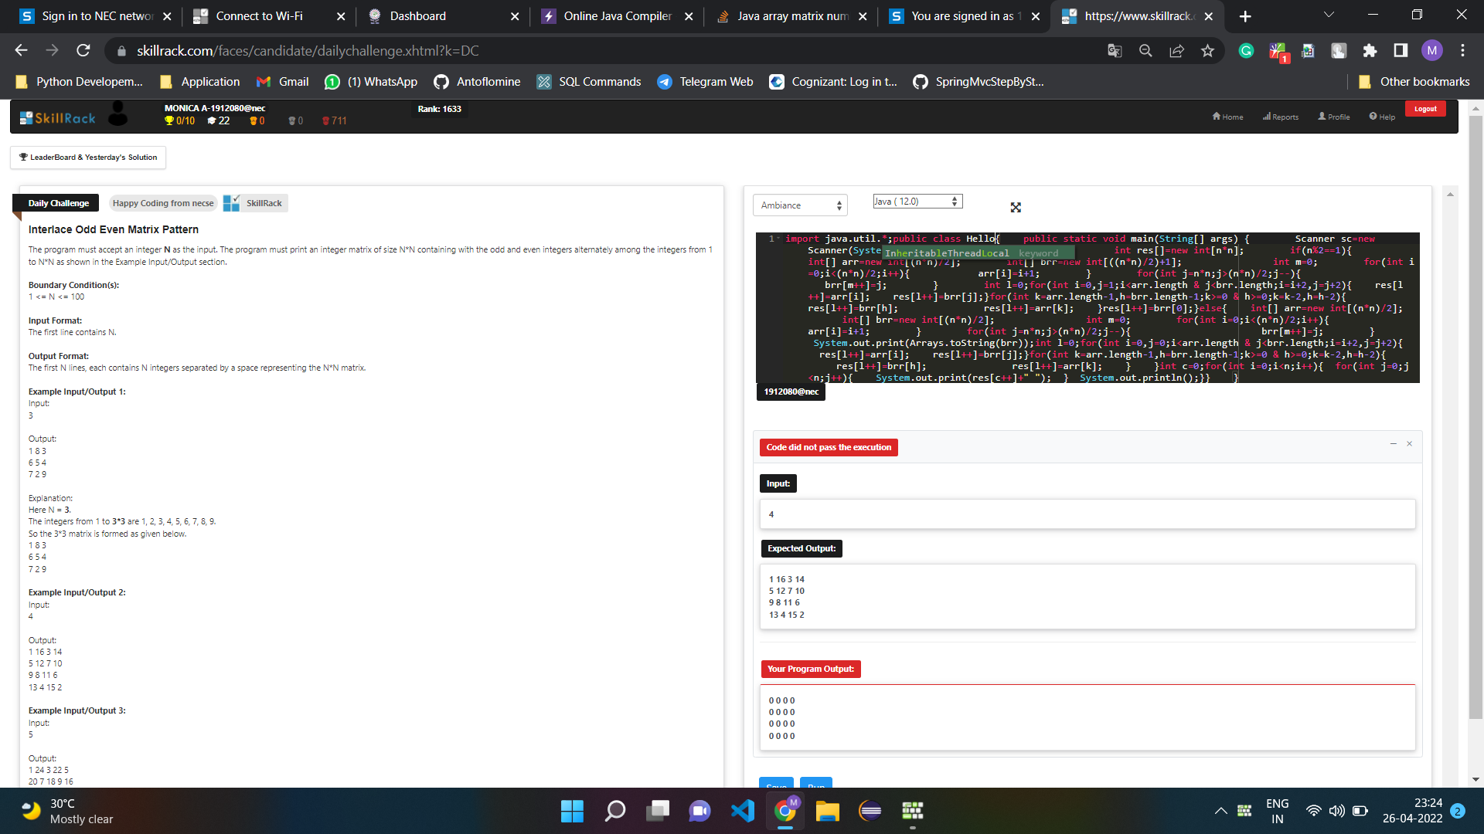

import java.util.\*;

public class Main{

public static void main(String[] args) {

Scanner sc=new Scanner(System.in);

int n=sc.nextInt();

int res[]=new int[n\*n];

if(n%2==1){

int[] arr=new int[(n\*n)/2];

int[] brr=new int[((n\*n)/2)+1];

int m=0;

for(int i=0;i<(n\*n)/2;i++){

arr[i]=i+1;

}

for(int j=n\*n;j>(n\*n)/2;j--){

brr[m++]=j;

}

int l=0;

for(int i=0,j=1;i<arr.length & j<brr.length;i=i+2,j=j+2){

res[l++]=arr[i];

res[l++]=brr[j];

}

for(int k=arr.length-1,h=brr.length-1;k>=0 & h>=0;k=k-2,h=h-2){

res[l++]=brr[h];

res[l++]=arr[k];

}

res[l++]=brr[0];

}

else{

int[] arr=new int[(n\*n)/2];

int[] brr=new int[(n\*n)/2];

int m=0;

for(int i=0;i<(n\*n)/2;i++){

arr[i]=i+1;

}

for(int j=n\*n;j>(n\*n)/2;j--){

brr[m++]=j;

}

System.out.print(Arrays.toString(brr));

int l=0;

for(int i=0,j=0;i<arr.length & j<brr.length;i=i+2,j=j+2){

res[l++]=arr[i];

res[l++]=brr[j];

}

for(int k=arr.length-1,h=brr.length-1;k>=0 & h>=0;k=k-2,h=h-2){

res[l++]=brr[h];

res[l++]=arr[k];

}

}

int c=0;

for(int i=0;i<n;i++){

for(int j=0;j<n;j++){

System.out.print(res[c++]+" ");

}

System.out.println();

}

}

}

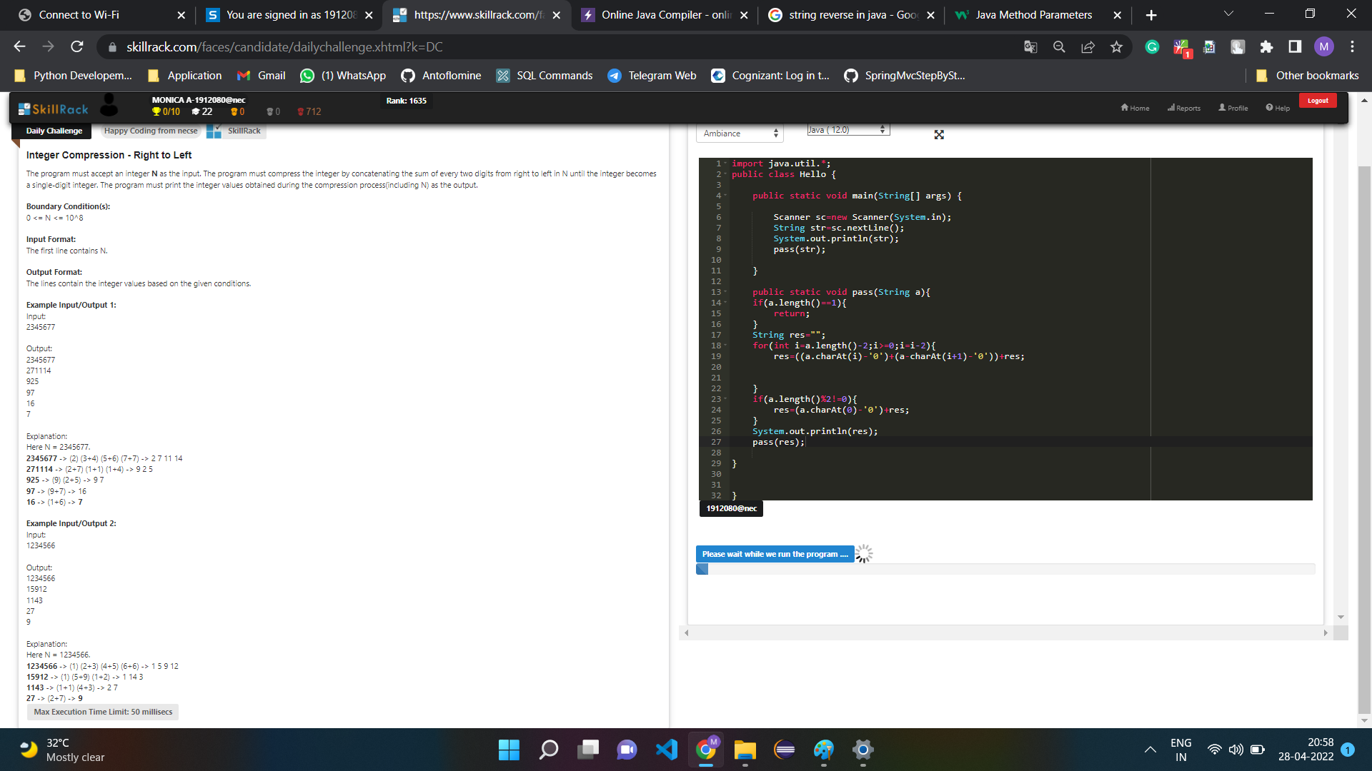

import java.util.\*;

public class Hello {

public static void main(String[] args) {

Scanner sc=new Scanner(System.in);

String str=sc.nextLine();

System.out.println(str);

pass(str);

}

public static void pass(String a){

if(a.length()==1){

return;

}

String res="";

for(int i=a.length()-2;i>=0;i=i-2){

res=((a.charAt(i)-'0')+(a.charAt(i+1)-'0'))+res;

}

if(a.length()%2!=0){

res=(a.charAt(0)-'0')+res;

}

System.out.println(res);

pass(res);

}

}

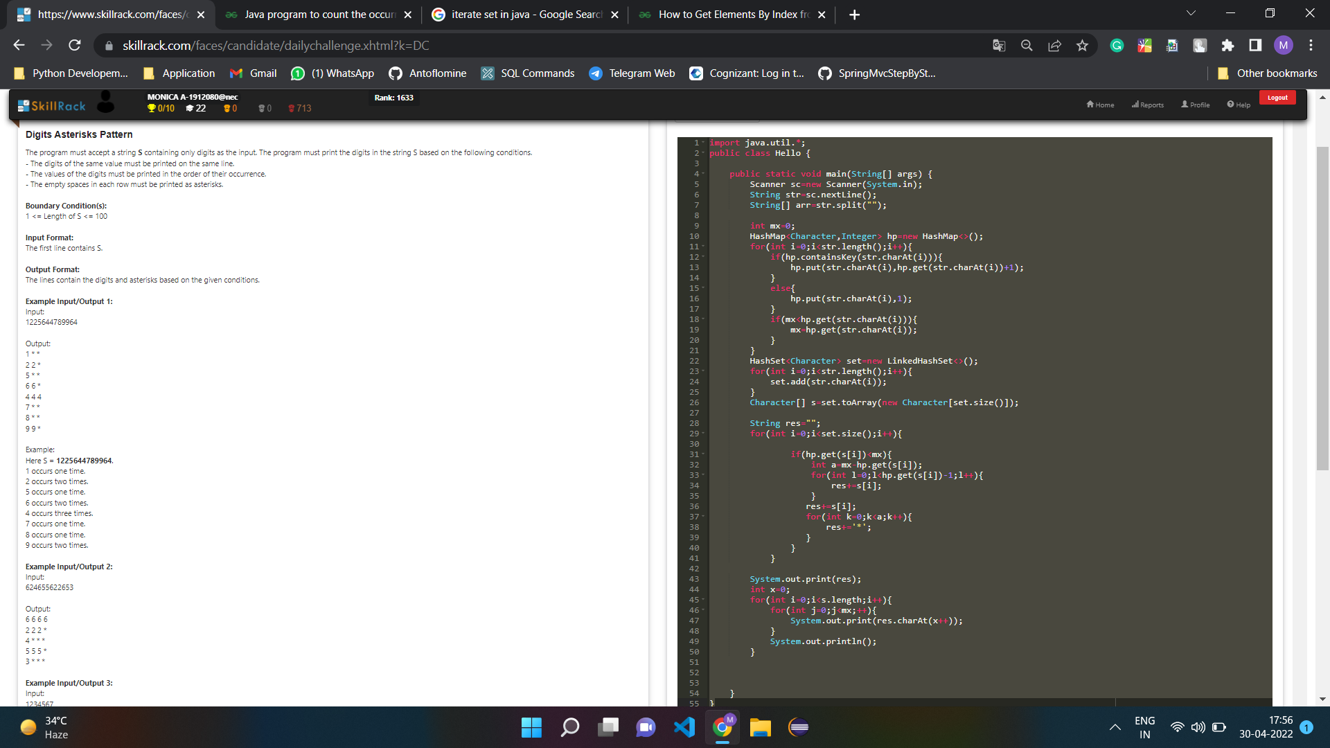

import java.util.\*;

public class Main {

public static void main(String[] args) {

Scanner sc=new Scanner(System.in);

String str=sc.nextLine();

String[] arr=str.split("");

int mx=0;

HashMap<Character,Integer> hp=new HashMap<>();

for(int i=0;i<str.length();i++){

if(hp.containsKey(str.charAt(i))){

hp.put(str.charAt(i),hp.get(str.charAt(i))+1);

}

else{

hp.put(str.charAt(i),1);

}

if(mx<hp.get(str.charAt(i))){

mx=hp.get(str.charAt(i));

}

}

HashSet<Character> set=new LinkedHashSet<>();

for(int i=0;i<str.length();i++){

set.add(str.charAt(i));

}

Character[] s=set.toArray(new Character[set.size()]);

String res="";

for(int i=0;i<set.size();i++){

if(hp.get(s[i])==mx){

for(int y=0;y<mx;y++){

res+=s[i];

}

}

if(hp.get(s[i])<mx){

int a=mx-hp.get(s[i]);

for(int l=0;l<hp.get(s[i])-1;l++){

res+=s[i];

}

res+=s[i];

for(int k=0;k<a;k++){

res+='\*';

}

}

}

// System.out.print(res);

int x=0;

for(int i=0;i<s.length;i++){

for(int j=0;j<mx;j++){

System.out.print(res.charAt(x++)+" ");

}

System.out.println();

}

}

}

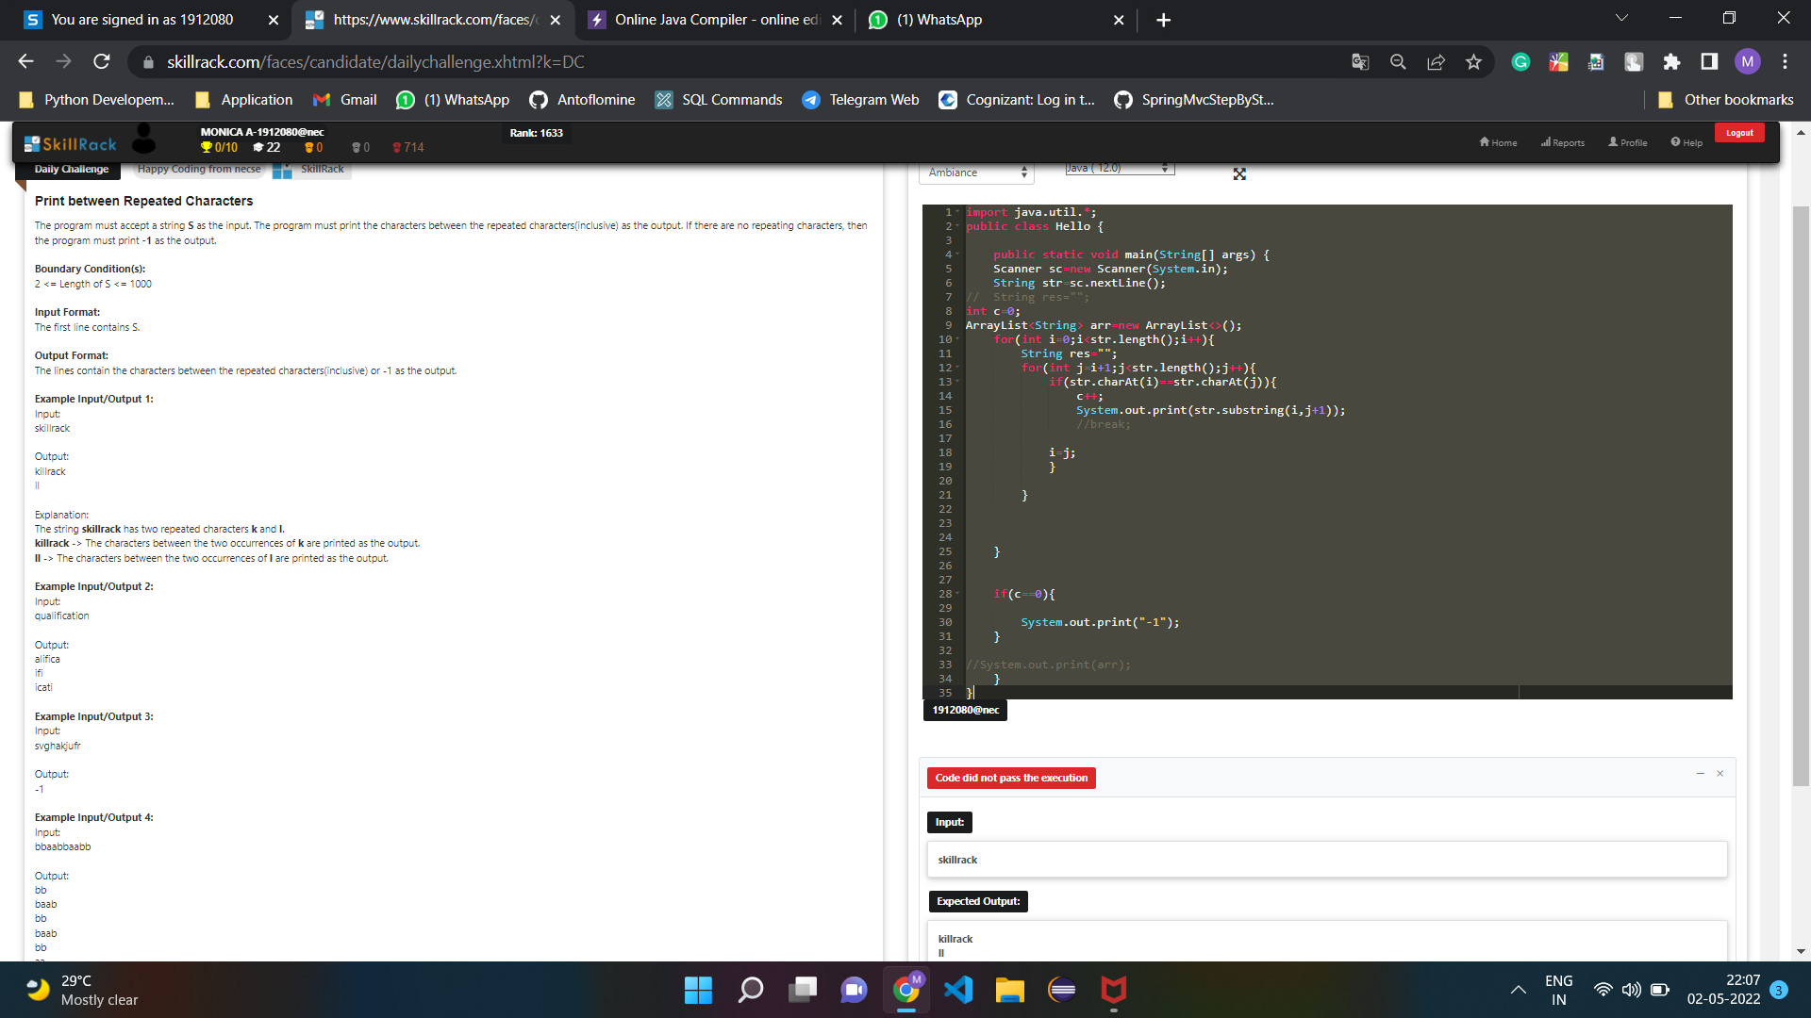

import java.util.\*;

public class Main{

public static void main(String[] args) {

Scanner sc=new Scanner(System.in);

String str=sc.nextLine();

//String res="";

int c=0;

ArrayList<String> arr=new ArrayList<>();

for(int i=0;i<str.length();i++){

String res="";

int j=i+1;

int ran=i;

while(j<str.length() && !res.contains(Character.toString(str.charAt(i)))){

if(str.charAt(i)==str.charAt(j)){

c++;

System.out.println(str.substring(ran,j+1));

ran=j;

//break;

}

j++;

}

res+=str.charAt(i);

}

if(c==0){

System.out.print("-1");

}

System.out.print(res);

}

}